**Visualizing Gerrymandering:**

**Efficiency Gap Analysis of the 2016 House of Representatives Election Results**

Carlos Sathler

I590 – Data Visualization

Professor Yong-Yeol (YY) Ahn

December 15, 2017

**Abstract**

Gerrymandering is the intentional carving of district boundaries to group or disperse segments of the population based on their inferred political preferences, in order to ultimately enable certain groups to elect more representatives, and therefore benefit one party over another. Gerrymandering threatens the very fabric of our democracy because it creates an imbalance of power favoring certain segments of society who are represented by the party that through gerrymandering have the ability to win more seats (representation) in congress. And it renders the political views and preferences of other segments of society inconsequential, since their ability to elect their party’s representatives are diminished. Our project explores the 2016 US House of Representatives election results and analyses representation imbalance at the national and state levels. We research existing visualizations that provide insights into gerrymandering and propose new ones, using the efficiency gap metric to identify gerrymandering; we offer a critique of this metric and assess its effectiveness. Finally we provide insights into the extent to which the representation issues identified at the US House of Representatives at the national level can be explained by gerrymandering in state elections.

# Introduction

Gerrymandering is “a practice intended to establish a political advantage for a particular party or group by manipulating [district boundaries](https://en.wikipedia.org/wiki/Boundary_delimitation)”.[1] According to the Brennan Center for Justice, there are 3 ongoing cases of gerrymandering being disputed in court.[2] One of them, *Gill v. Whitford*, has reached the US Supreme Court. The plaintiffs contend the Wisconsin Legislature has hindered their First and Fourteenth Amendment rights by favoring the republican party in the way the legislature drew district lines after the census of 2010. Gerrymandering is a spurious political practice because it has the potential to silence a political party and make its political views and proposals inconsequential, threatening therefore the very fabric of our democracy.

An easy way to explain gerrymandering is illustrated in Figure 1 below.[3]

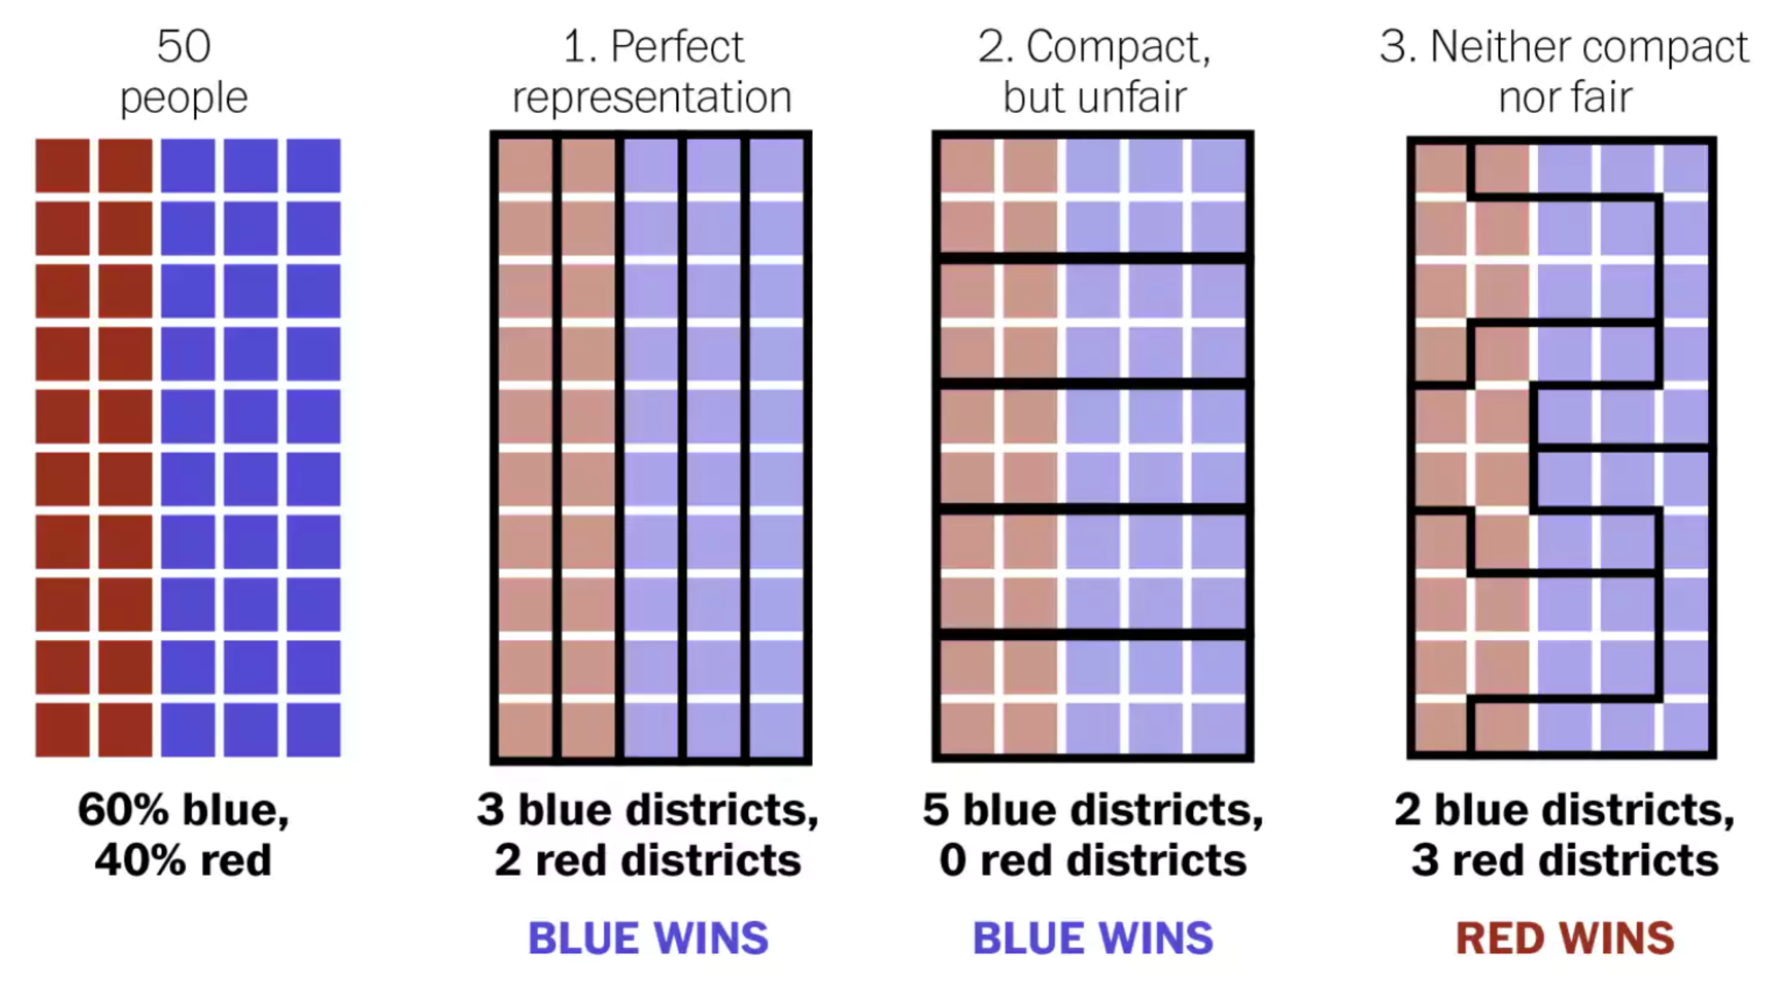

Figure 1 – The best explanation of gerrymandering you will ever see.3

The leftmost picture in Figure 1 represents a population of 50 people in a hypothetical rectangular state. Imagine this state can elect 5 representatives to the US House of Representatives, each representing 10 people. Since the proportion of red and blue voters is 2:3, a perfectly fair election would elect 2 representatives of the “red” party and 3 representatives of the “blue” party to the House of Representatives.

The grouping of voters by boundaries inside a state is called “districting”. Districts are redefined every 10 years based on census numbers, so that each district have the same population. Each electoral district in a congressional election will elect a single representative.[4] On Figure 1, the second picture on the left shows district boundaries achieving ideal representation; the third and fourth show examples of districting that favor one or the other party. The third illustration favors “blue” voters and the fourth favors “red” voters.

The main motivation for our project is the identification of states where one party is blatantly under/over represented due to unfair districting, i.e. gerrymandering. We will primarily use the concept of “efficiency gap” for our analysis. This concept was conceived for the specific purpose of assessing gerrymandering[5],[6] and is being used in the current Wisconsin gerrymandering case *Gill v. Whitford*.[7],[8]

Central to the “efficiency gap” metric is another concept called “wasted vote”. A “wasted vote” is a vote that does not contribute to win an election. So all votes for a losing candidate are “wasted” in that sense, and all votes for a winning candidate beyond simple majority are also “wasted”. The efficiency gap is calculated as “the difference between the two parties' wasted votes, divided by the total number of votes”.[9] The metric therefore measures the percentage of votes that failed to contribute to place a party’s candidate on an electoral seat.

The issue of vote “efficiency” and “waste” can be well illustrated by the 2016 congressional election results shown in Figure 2. According to the Wikipedia infobox for the United States House of Representative Elections, 201610 Republicans received 49.1% of the popular votes while Democrats received 48%. Yet Republicans won 241 seats while Democrats only won 194; *the Republican Party was able to convert 1% more votes into 24% more seats in the congress.*

# 

Figure 2

Section from United States House of Representative Elections, 2016 Wikipedia info box[10]

But gerrymandering should not be considered the only possible cause of disproportional representation and wasted votes. As stated before, congressional elections for the US House of Representatives follow the single member district (SMD) voting system, also called “winner-takes-all”. In this system either party can potentially have a large number of votes across all districts in a state that is not gerrymandered and still end up with zero representation. If the opposing party wins every district by a small margin the number of wasted votes for the loosing party could be huge.

Our project delivers visualizations that provide insights into the connection between the imbalance portrayed in Figure 2 and gerrymandering. We contrast efficiency gap numbers for different states and we analyze if representational issues at each state can be attributed to gerrymandering of district lines, or if they most likely result *not* from gerrymandering *but* from the “winner-take-all” (SMD) electoral system.

Representation issues caused by gerrymandering threaten first amendment and fourteenth amendment rights by curtailing citizen’s ability to express their views and have equal rights to elect candidates that support their agenda. Gerrymandering threatens the very fabric of our democracy because it creates an imbalance of power favoring certain segments of society who are represented by the party that through gerrymandering have the ability to win more seats (representation) in congress. And it renders the political views and preferences of other segments of society inconsequential, since their ability to elect their party’s representatives are diminished.

We hope that our visualizations highlighting disproportional representation due to possible gerrymandering will raise awareness to existing districting issues, so that voters become motivated to join by-partisan efforts to stop gerrymandering (such as FairVote[11]) thus contributing to a fairer electoral system and a stronger democracy.

# Efficiency Gap Computation

Nicholas O. Stephanopoulos and Eric M. McGhee in their article Partisan Gerrymander-ing and the Efficiency Gap5, detail how to calculate the efficiency gap metric. On the surface, the calculation is simple: calculate the number of wasted votes by each party and divide it by the total votes in the state. The party with less wasted votes is considered “favored” and the efficiency gap metric is the ratio of net wasted votes divided by the total votes in the state.

But this approach is problematic for states with uncontested districts. These are districts in which a party candidate receives all votes in the district, either because he/she runs unopposed, or because his/her opposing candidate is not in the ballot (write-ins). In such cases the losing party will have zero wasted votes, and it is difficult to interpret how many of the winning votes are wasted, since in theory a single vote could have potentially won the election for the uncontested candidate.

Nicholas O. Stephanopoulos and Eric M. McGhee suggest one should impute the votes of the losing party in unopposed districts, either using past election data, or choosing a percent value of total district votes, such as 25%. The authors admit, “the efficiency gap can be sensitive to the treatment of uncontested seats”.[12]

In our project we chose to *not* impute votes for the losing party in uncontested districts. We will consider wasted votes for the losing party in uncontested districts to be zero and we will consider wasted votes for the winning party to be half the votes in the district minus one. It is important to realize our decision increases the ratio of wasted votes for the party winning most uncontested seats in a given state.

# Research Questions and Working Hypotheses

Considering the issues of disproportional representation in the US House of Representatives, our project aims at answering two main questions:

1. Is gerrymandering the cause of this disproportional representation?
2. How well can the efficiency gap identify gerrymandering?

At the onset of the project we hypothesized that gerrymandering would be considered the main cause of the disproportional representation in the US House of Representatives and we were confident the efficiency gap would be a good indicator of gerrymandering.

One word of caution when studying gerrymandering: as stated by Altman, Micah, et al.[13] in the abstract to their paper Revealing Preferences: Why Gerrymanders are Hard to Prove, and What to Do about It, “gerrymandering requires illicit intent”. With that in mind, we refrain in our project to ever state categorically that this or that state *is* gerrymandered. One cannot know the intent of those in charge of districting a state, and whether they had spurious motivations to favor their party. However, because bias is inevitable, and because politics stimulates fierce competition, it is reasonable to suspect gerrymandering is at play in certain states, particularly when certain conditions that we will discuss later apply. When we see these conditions on a given state, we will make a claim that gerrymandering *could* be at play in that state, or that we *suspect* the state is gerrymandered. A full evaluation of whether or not that is true would require research into the process of districting in that state, as well as additional data showing population distribution and demographics in the state.

# Overview of Existing Visualizations on Gerrymandering

We identified many visualizations that explain gerrymandering with play data,[14],[15] including the one included herein as Figure 1. There are many visualizations on the web showing maps of districts with highly irregular boundaries that indicate the possibility of gerrymandering, but do not include any data analysis.15,[16],[17] The online game “The Redistricting Game”[18] is worth mentioning because it offers an excellent opportunity for regular citizens to understand how gerrymandering works. In the game players engage in districting a fictitious state to achieve political advantage.

In addition to the issue of wasted votes and disproportional representation that we explore in our project, there are at least two other relevant issues associated with gerrymandering. One of them is well explained in two videos featuring Governor Arnold Schwarzenegger.[19],[20] Governor Schwarzenegger outlines how politicians engage in gerrymandering to perpetuate themselves in the US House of Representatives, regardless of their performance. We found visualization that corroborates Mr. Schwarzenegger assertion. According to OpenSecrets.org the US House of Representatives re-election rate in the period of 1964-2016 was seldom less than 85%.[21] Mr. Schwarzenegger created a “Crowdpac” to combat gerrymandering.[22]

The second issue that motivated our project is related to the possible impact of gerrymandering in the perceived growing polarization of our political system.22,[23],[24] Nate Silver’s visualization (Figure 3) is insightful.[25]

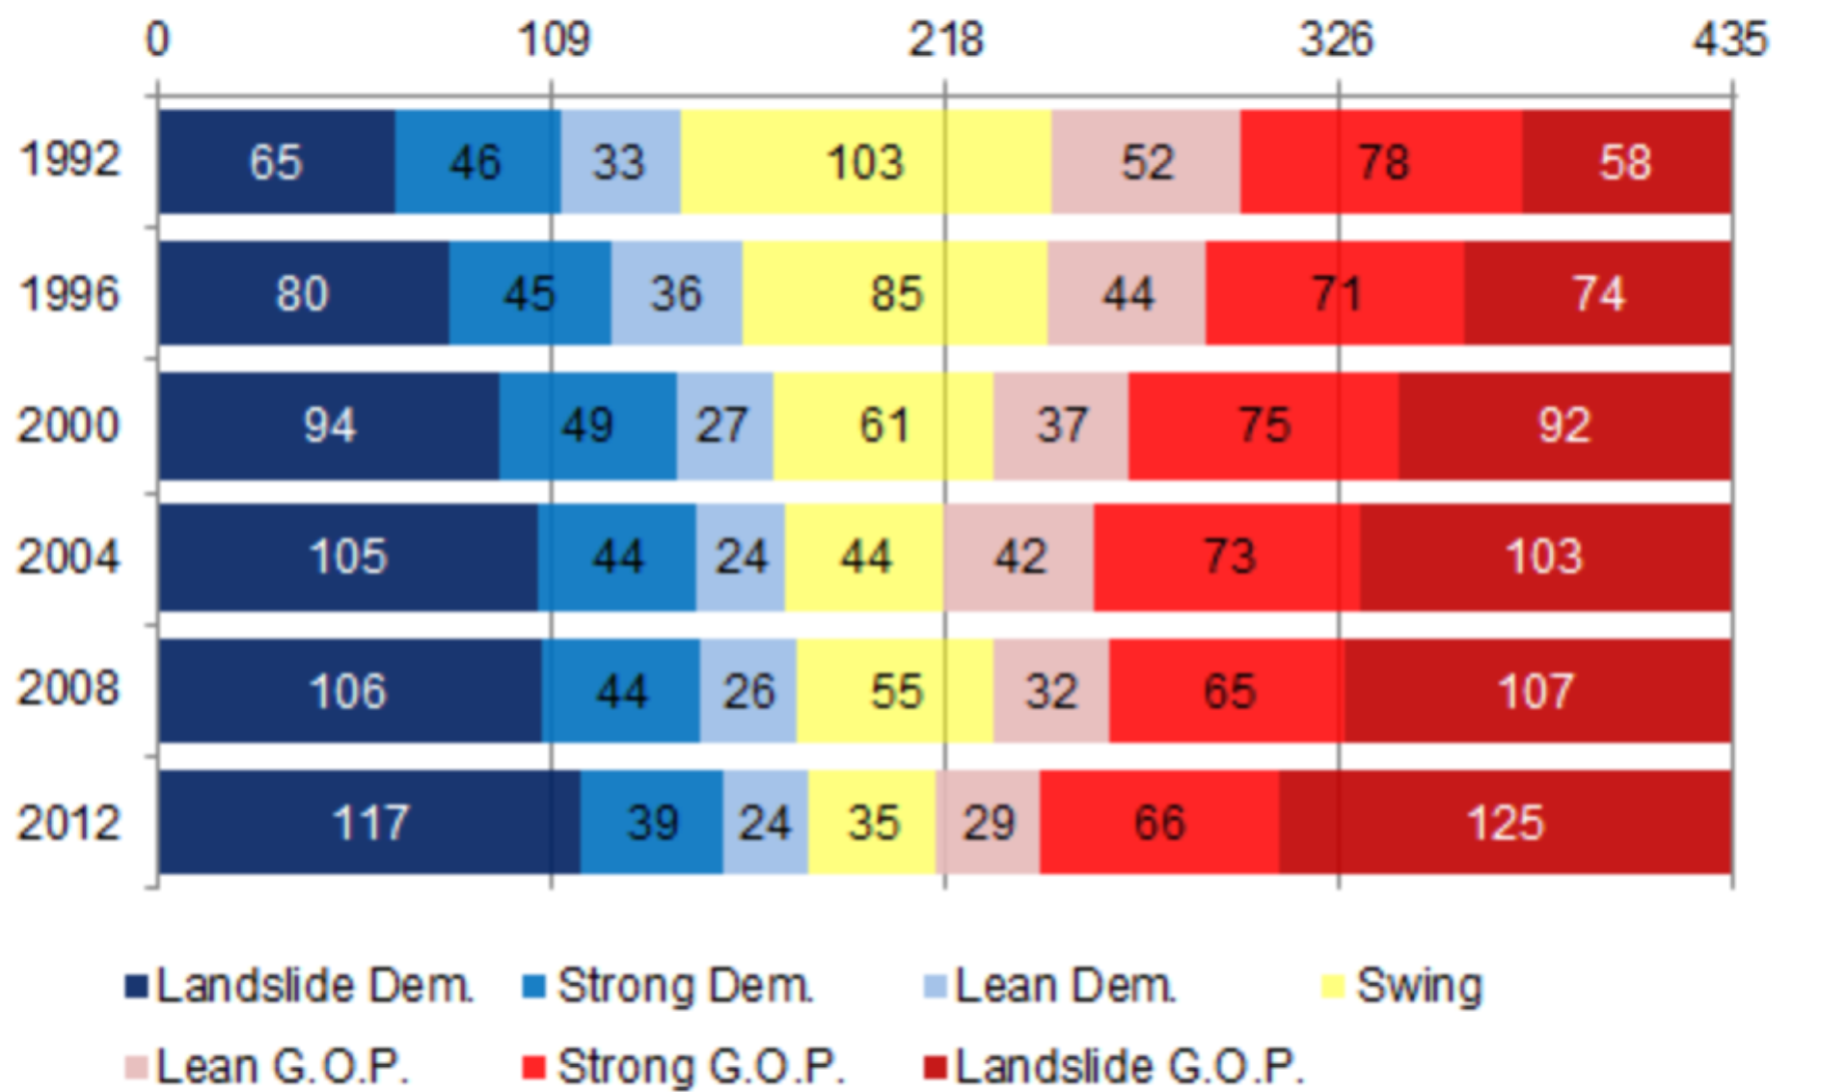

Figure 3

Nate Silver on the Increasing Polarization in our Elections

One possible way to approach the topic is the Cook Partisan Voting Index[26],[27] which measures “how strongly a United States [congressional district](https://en.wikipedia.org/wiki/Congressional_district) or [state](https://en.wikipedia.org/wiki/U.S._state) leans toward the [Democratic](https://en.wikipedia.org/wiki/Democratic_Party_%28United_States%29) or [Republican](https://en.wikipedia.org/wiki/Republican_Party_%28United_States%29) Party, compared to the nation as a whole”.26 We found one visualization that further analyzes this data: The State of Gerrymandering, created by an organization called Silicon Valley Data Science.[28] Data used by the company is available in GitHub.[29]

We do not analyze polarization in our project, but the Silicon Valley Data Science visualization also shows % of votes for each party, and corresponding seats won. The arrows in the screenshot in Figure 3 show two nice features of the visualization. First, we see how “squiggly” a district is relative to others in the nation. Second, we see a count of actual vs. expected party wins, based on the percent number of votes for the party. The visualization is a bit busy. Even though I selected %VOTERS the page shows PVI score and we will see on the next example in Figure 5 how the % of voters information can be combined with the actual vs. expected win count in a more compact way.

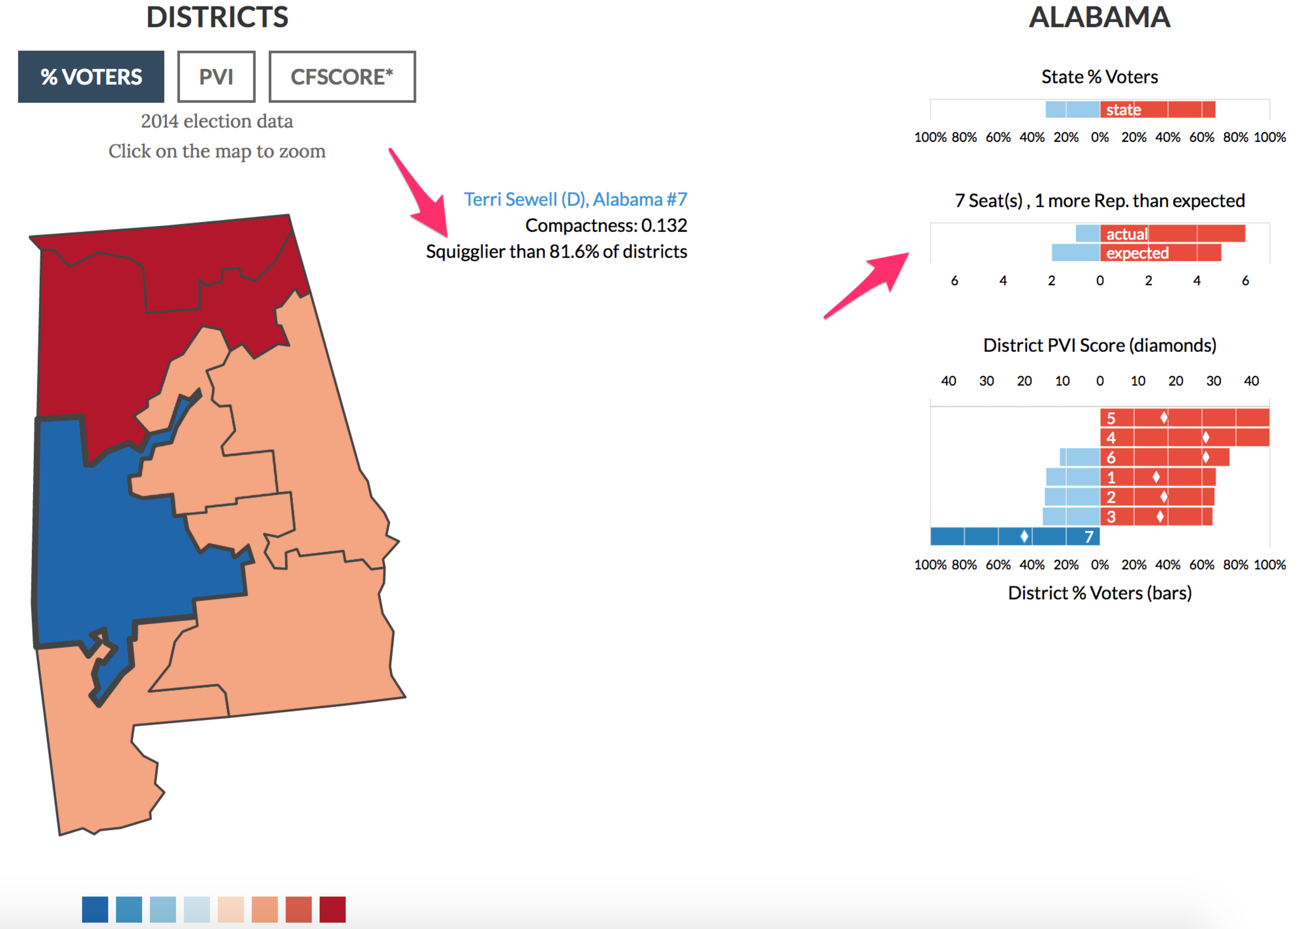

Figure 4

Silicon Valley Data Science Visualization28

Patrick Han’s blog entry The Most Gerrymandered States Ranked by Efficiency Gap and Seat Advantage[30] includes a visualization (Figure 5) that offers great insight into gerrymandering by comparing % of votes with actual vs. expected seat wins by a party, alongside a district map of each state. Data is not available. Note that Patrick Han uses a 25% of votes for the losing party in the calculation of efficiency gap for uncontested wins. We are not convinced this approach is sound. As stated before, in our calculations we consider zero votes for the opposing party in uncontested districts. The second plot by Patrick Han (Figure 6) shows efficiency gap numbers expressed as total lost seats by state.

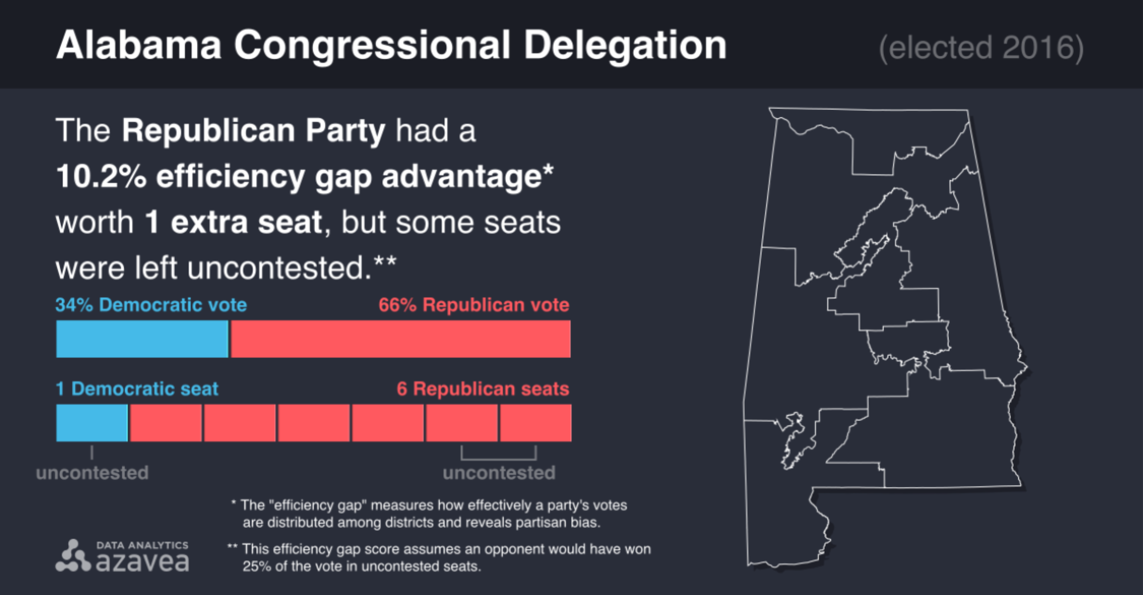

Figure 5

Patrick Han’s Visualization for Alabama30

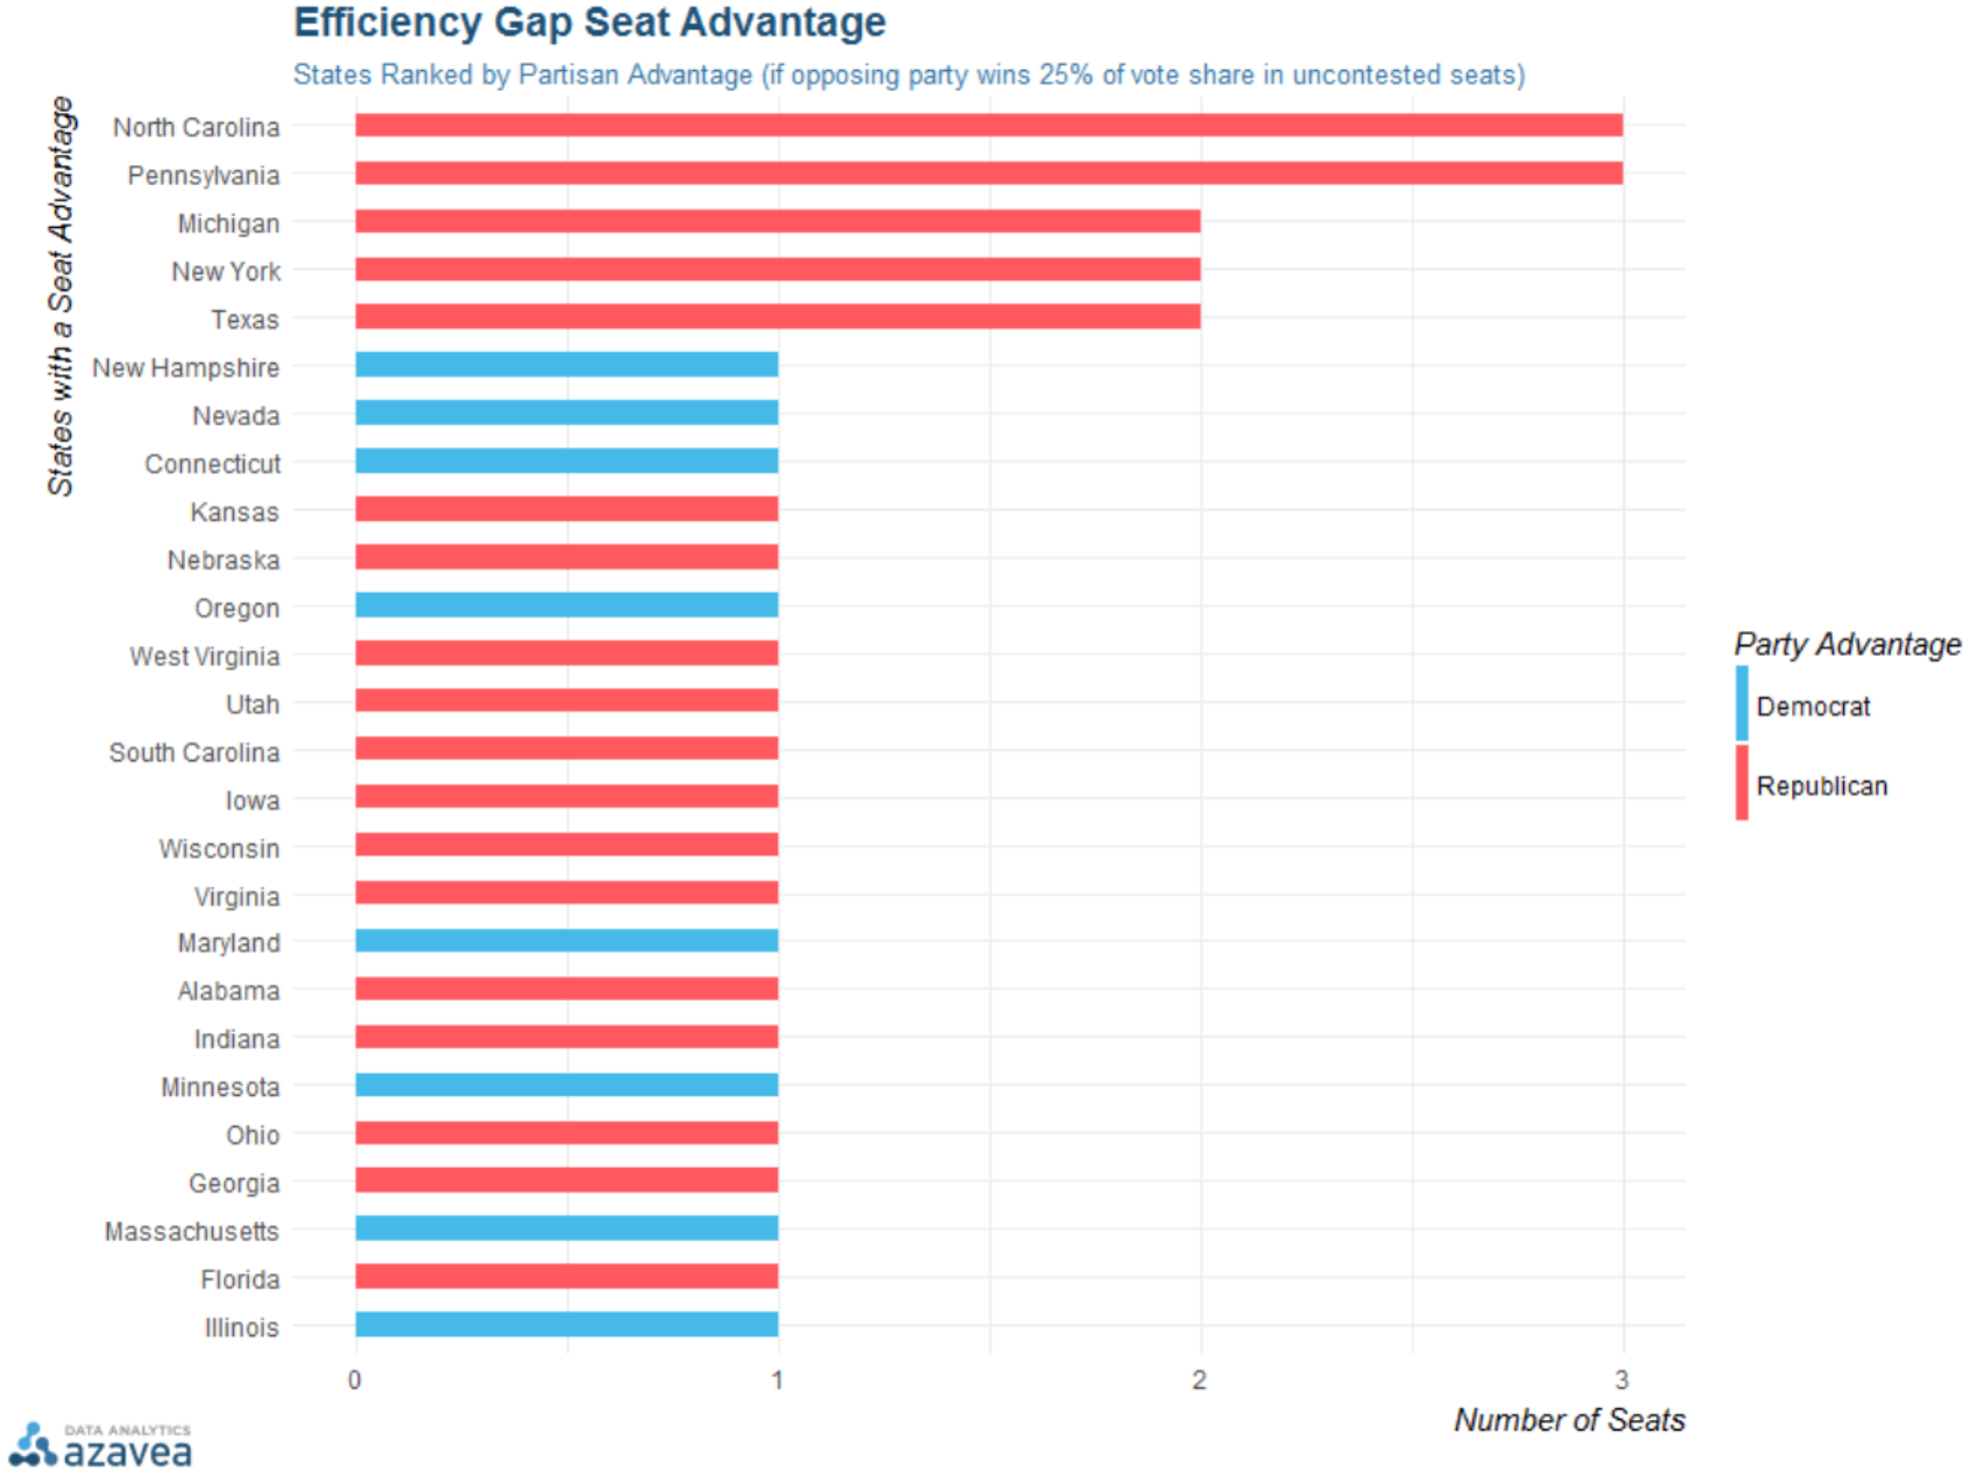

Figure 6

Patrick Han’s Visualization for Efficiency Gap Advantage30

An example of even more compact way to show percentage of votes in contrast with number of seats won is offered by Nate Silver on a New York Times visualization.[31] It does not show however the number of seats won as an integer, which is a nice feature of Patrick Han’s visualization.

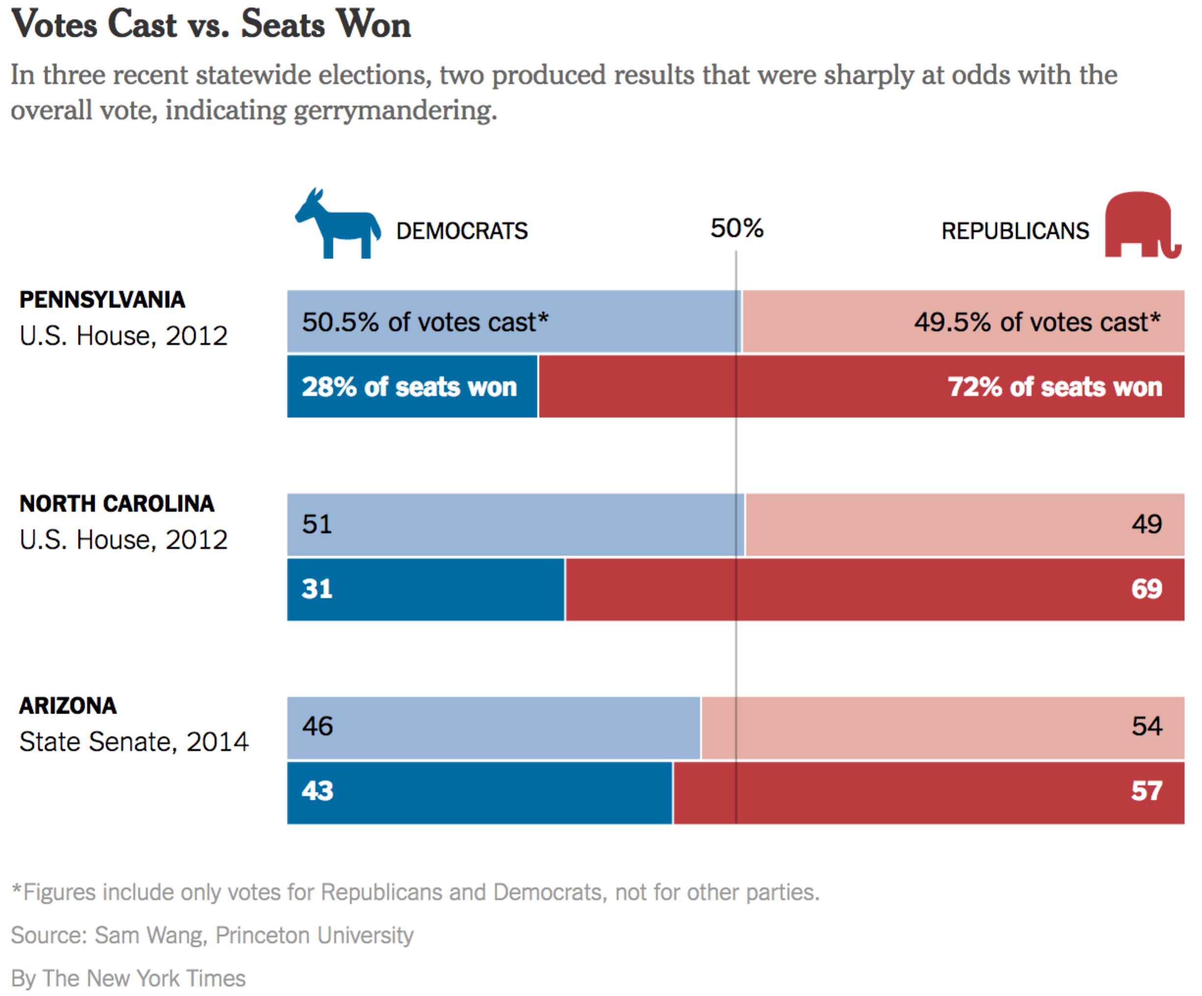

Figure 7

Votes Cast vs. Seats Won Visualization32

The last visualization we wish to mention is from the Princeton University website gerrymander.princeton.edu.[32] It has many useful links, proposes a test to determine if a state is gerrymandered, and allows users to explore how gerrymandered their state is (Figure 8). The color scale on the map goes from “unlikely to be gerrymandered” (green) to “definitely gerrymandered” (red), and suggests number of seats gained due to gerrymandering. The color choice for the scale is not ideal but seeing all states categorized based on gerrymandering is very insightful. The website uses three statistical tests to assess gerrymandering.[33] The tests do not include efficiency gap analysis.

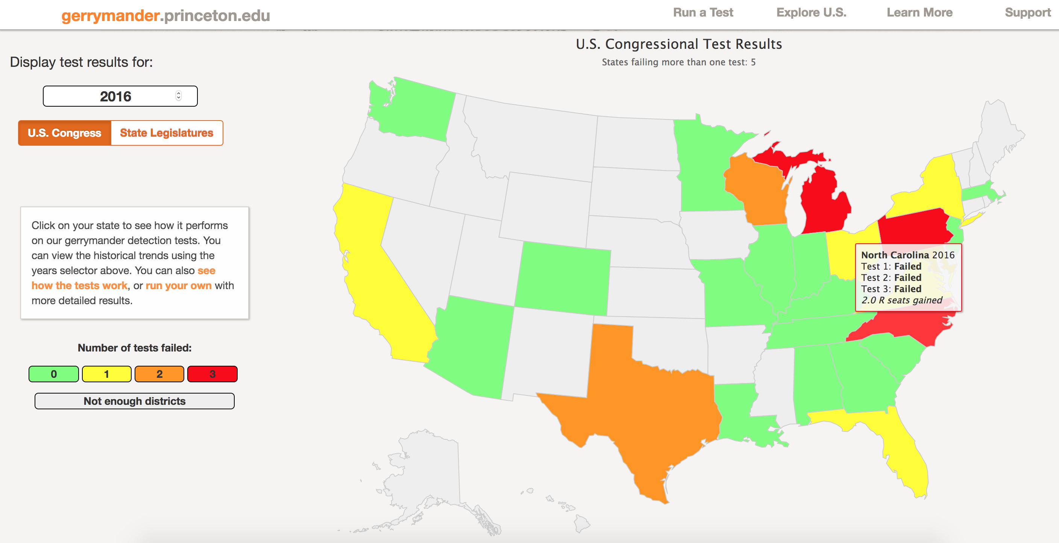

Figure 8

gerrymander.princeton.edu32

# Project Unique Contributions

Unlike the visualizations we identified in our research, our project explores gerrymandering using a top down approach that starts from an analysis of election results at the national level, and drills down to states using number of votes needed to elect house representatives as the starting point of our analysis.

We extrapolate the common notion of “power”, defined in the Merrian-Webster dictionary as “the ability to act or produce an effect” to mean the ability to successfully elect a candidate of one’s choice.[34] We produce visualizations to show that power is not equitably distributed across the electorate, in the sense that electors from certain parties, in different states, are able to elect their representatives with fewer votes than their opponents. At the national level, we confirm the Wikipedia infobox from Figure 2; in the whole, in the 2016 House of Representative elections, republican electors had more power than democrat electors.

We believe our approach provides a context in which to analyze gerrymandering that is useful because it highlights how this practice contributes to a larger issue. In fact, if we agree with the Declaration of Independence that “all men are created equal”[35] there is no reason we should accept that certain electors possess more power than others - power in the sense we discussed above. So, redistricting that risks creating an imbalance of electoral power is immoral, whether unlawful or not. We hope the flow of our visualizations provide new insights into the issues of electoral power and representation associated with gerrymandering.

A second unique contribution of our project is the *election result summary* visualization, which we believe combine in a single visualization all high level data needed for the analysis of possible gerrymandering in a state. We illustrate the insights possible with this visualization using the state of Alabama as an example.

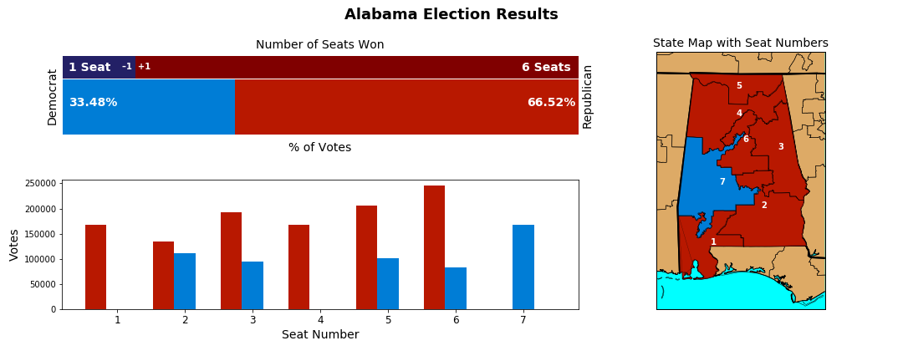

The top plot on the left contrasts percentage of votes with seats won and shows how many seats each party lost/won relative to the votes they received in the state. In the example below, for Alabama, we see democrats were one seat short of what they would have won if the election awarded a number of seats proportional to number of votes. Conversely, republicans won one seat too many relative to the proportion of votes they received in the state.

The second plot on the bottom left, showing number of votes per party per district provides viewers with more direct insight into the possibility of gerrymandering, as we explain next:

There are two strategies to gerrymander a state. The first one is to draw district lines to dilute the votes of one party across many districts, so the unfavoured party will win fewer elections at the district level, or none at all; that is called “cracking”.[36] The second strategy is to concentrate votes of a party in a few districts, where that party will then win in a landslide, leaving other districts open for easy wins by the opposing party – that is called “packing”.36

In the state of Alabama the bottom left plot shows that both “cracking” and “packing” appear to be at play. Districts 2 and 3 are adjacent; it is conceivable that district lines were intentionally drawn to split (“crack”) blue votes. District 7 is close to district 5; it is conceivable that district lines were intentionally drawn to isolate blue votes in district 7, ensuring a red win in district 5 (“packing”).

Finally, the district map of the state allows viewers to assess if seats where “cracking” may have occurred are adjacent to each other or to districts where packing may have occurred. In the Alabama example, we see that districts 2 and 7 are adjacent, perhaps indicating that “packing” of democrat votes in district 7 was intentional and aimed at reducing the chances of democrats winning the district 2 seat, which was a close race. The map on the right side of the visualization allows viewers to analyze the shape of districts and district lines. Highly irregular shapes and squiggly district lines could mean the party in control of a state’s legislature body has gone through a concerted effort to favor the state’s majority party. In the case of Alabama, the highly irregular shape of district 7 is suspicious.

# Data

Project data was scraped from the New York Times (NYT) House Election Results: G.O.P Keeps Control webpage,[37] seen in Figure 3 below. Election results data at state district level is stored in a single variable in the html code, in JSON format, so it was relatively straightforward to parse the file to obtain election results data, and create the raw dataset for the project.

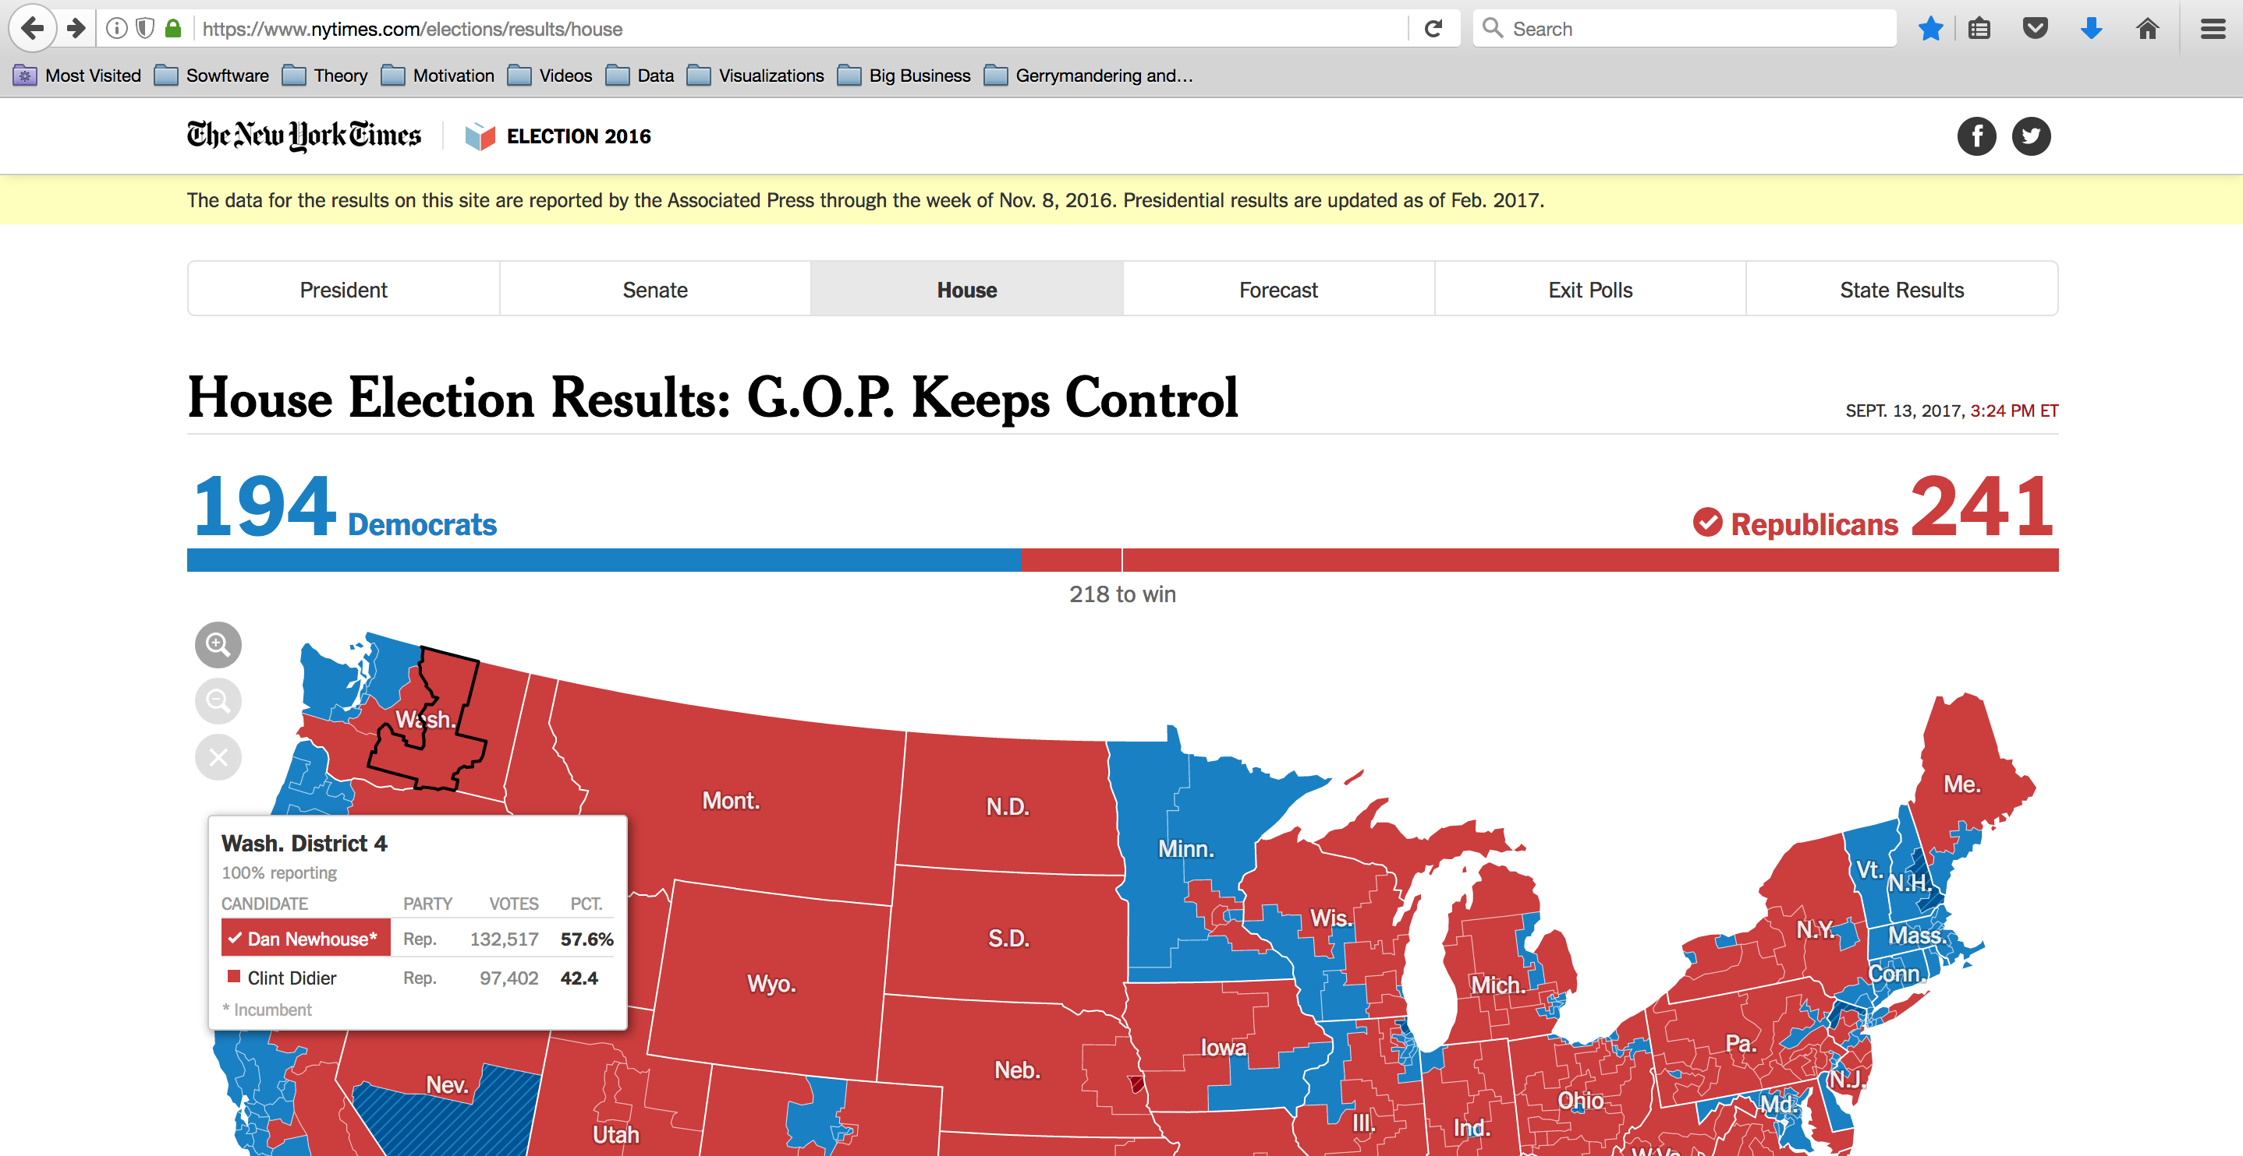

Figure 9

New York Times webpage “House Election Results: G.O.P. Keeps Control”.37

Structure of the raw dataset:

| **#** | **Column** | **Descr** | **Data type** | **Comment** |
| --- | --- | --- | --- | --- |
| 1 | candidate_id, ' | Candidate ID | String, Nominal | Unique at country level (dataset) |
| 2 | candidate_key | Candidate Key | String, Nominal | Unique at state level |
| 3 | first_name | Candidate’s first name | String, Nominal |  |
| 4 | incumbent | Incumbent? | Boolean | True or NaN |
| 5 | last_name | Candidate’s last name | String, Nominal |  |
| 6 | name_display | Candidate’s full name | String, Nominal |  |
| 7 | order | Ordering when displaying candidate in the NYT source webpage | Integer, Ordinal | Sort by number of votes descending at the state level |
| 8 | party_id | Party of candidate | String, Categorical | There are 25 distinct party values |
| 9 | percent | Percentage of votes received. | Float, Continuous |  |
| 10 | percent_display | Percentage of votes received. | Float, Continuous |  |
| 11 | seat | District number | Integer, Categorical | Seat is a synonym to district number |
| 12 | state_id | Tow letter state abbreviation | String, Categorical | There are 50 distinct states in the dataset, as expected |
| 13 | votes | Number of votes received | Integer, Discrete |  |
| 14 | winner | Winner? | Boolean | True or NaN |

Pre-processing included many clean up steps and a large number of aggregations and summarizations to allow visualization programs to retrieve data directly with minimal to no need for additional data processing. The NYT data source did not contain vote counts for the many uncontested wins in the 2016 election. Votes for uncontested wins were imputed as the average number of votes per district for the corresponding state.

Project code can be found at <https://github.com/csathler/IU_MSDS/tree/master/DViz/project>

# Ideas, Sketches, and Prototypes

To illustrate initial visualization ideas for the project, we first explored examples of efficiency gap on paper, using Figure 1 from the introduction. Below we show one example of such explorations. The calculations are based on Eric Petry’s explanation of the efficiency gap in the article How the Efficiency Gap Works.[38]

Example: Heavy gerrymandering, high irregular district boundaries. From Figure 1, 3nd scenario; assumes districts are numbered top to bottom, left to right.

|  | **Red Votes** | **Blue Votes** | **Wasted Red** | **Wasted Blue** | **Net Wasted** |
| --- | --- | --- | --- | --- | --- |
| District 1 | 6 | 4 | 0 | 4 | 4 Blue |
| District 2 | 6 | 4 | 0 | 4 | 4 Blue |
| District 3 | 6 | 4 | 0 | 4 | 4 Blue |
| District 4 | 1 | 9 | 1 | 3 | 2 Blue |
| District 5 | 1 | 9 | 1 | 3 | 2 Blue |
| Totals | 20 | 30 | 2 | 18 | 16 Blue |

Net 16 blue votes wasted / 50 total votes = 32% efficiency gap favoring red voters

After creating the dataset for the project, we were naturally drawn to pursue a top down approach starting with issues of representation at the national level, as illustrated in Figure 2. Later, due to some unsuccessful visualizations we further realized that gerrymandering and the efficiency gap only make sense under certain circumstances; only when the proportion of votes for a party exceeds the proportion of seats won by a full whole numbers does it make sense to consider the efficiency gap. In other words, unless a party has enough votes in the state to elect at least one more candidate, redistricting to benefit the loosing party wouldn’t grant the party an extra seat anyway.

Analysis of wasted votes was another idea we pursued and abandoned. Figure 4 shows a visualization we will not use in the final project because wasted votes need to be considered in context and we did not find a good context yet in which to present this metric.

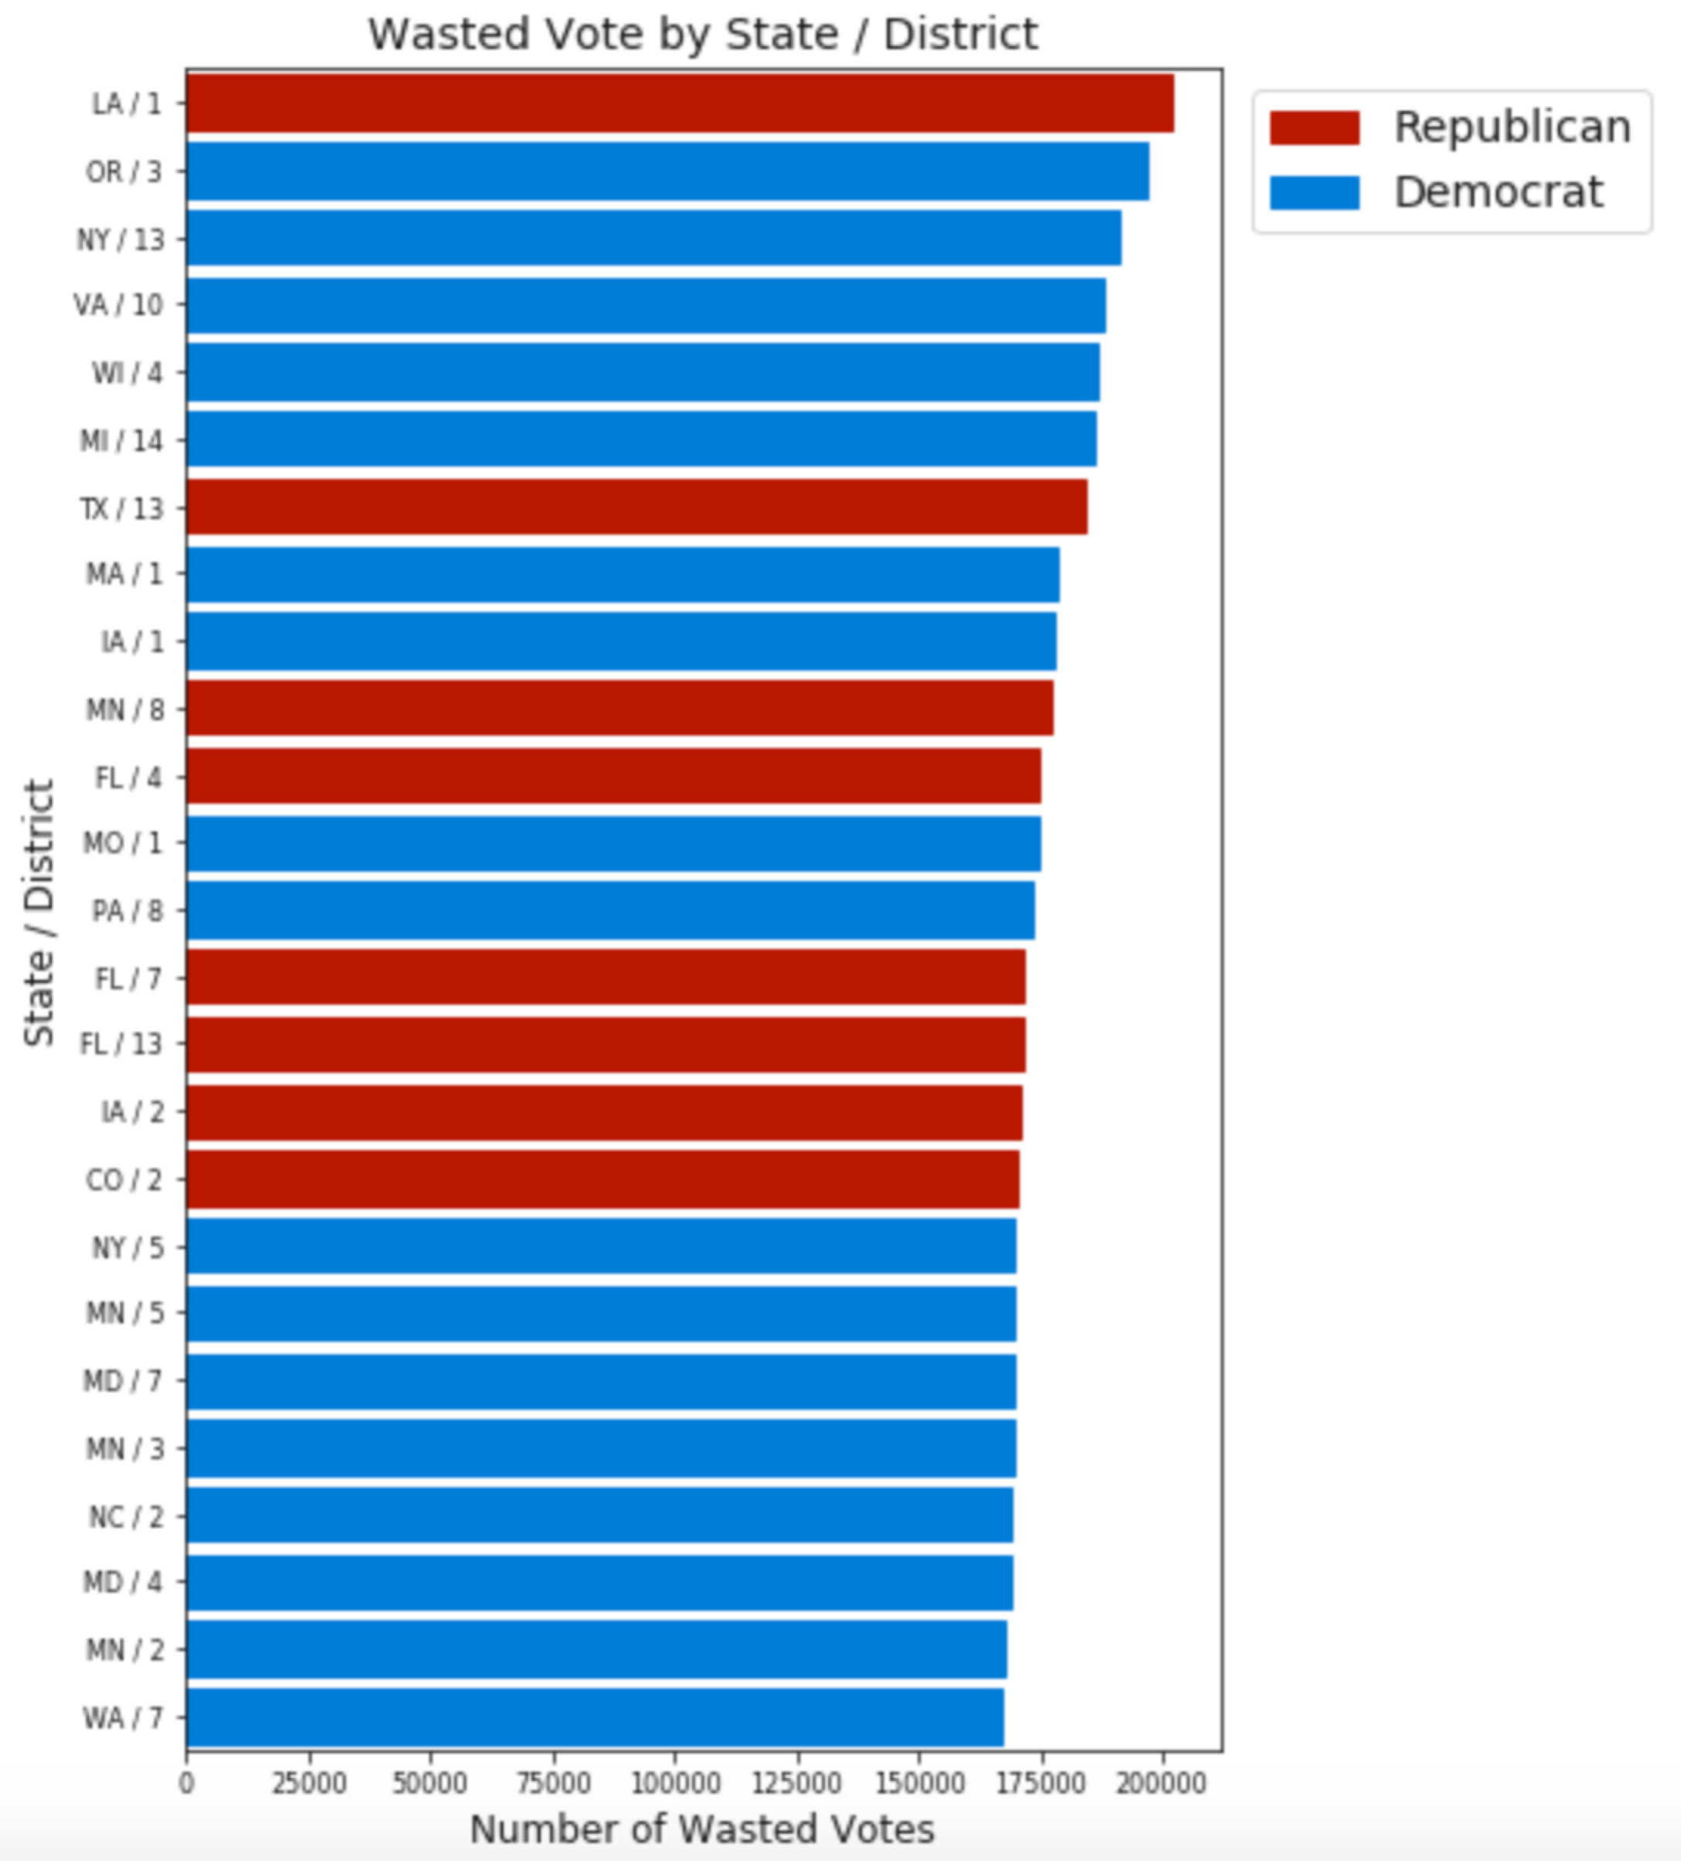

Figure 10

Abandoned visualization showing wasted votes per state / district

These were initial plot ideas we considered. Some of them were selected.

1. Efficiency gap by state (bar chart or heat map with tabular data)
2. Districts with highest relative number of wasted votes (same as above)
3. Seats lost due to districting, by state (percentage of votes vs. percentage of seats)
4. Seats gained due to districting, by state (same as above)

These were ideas for iterative capabilities put forth at the beginning of the project:

1. Allow user to generate plot(s) by first selecting a state
2. Allow user to generate plot(s) by first select top/bottom states on a particular metric
3. Allow user to generate plot(s) that display total for entire country
4. Add links to the plots so user can jump to Congressperson’s webpage
5. Add links to organizations that are fighting gerrymandering
6. Add links to pages that educate on the subject

We did not find the time to build an interactive visualization.

Some of the prototypes used during design of visualizations are included below:

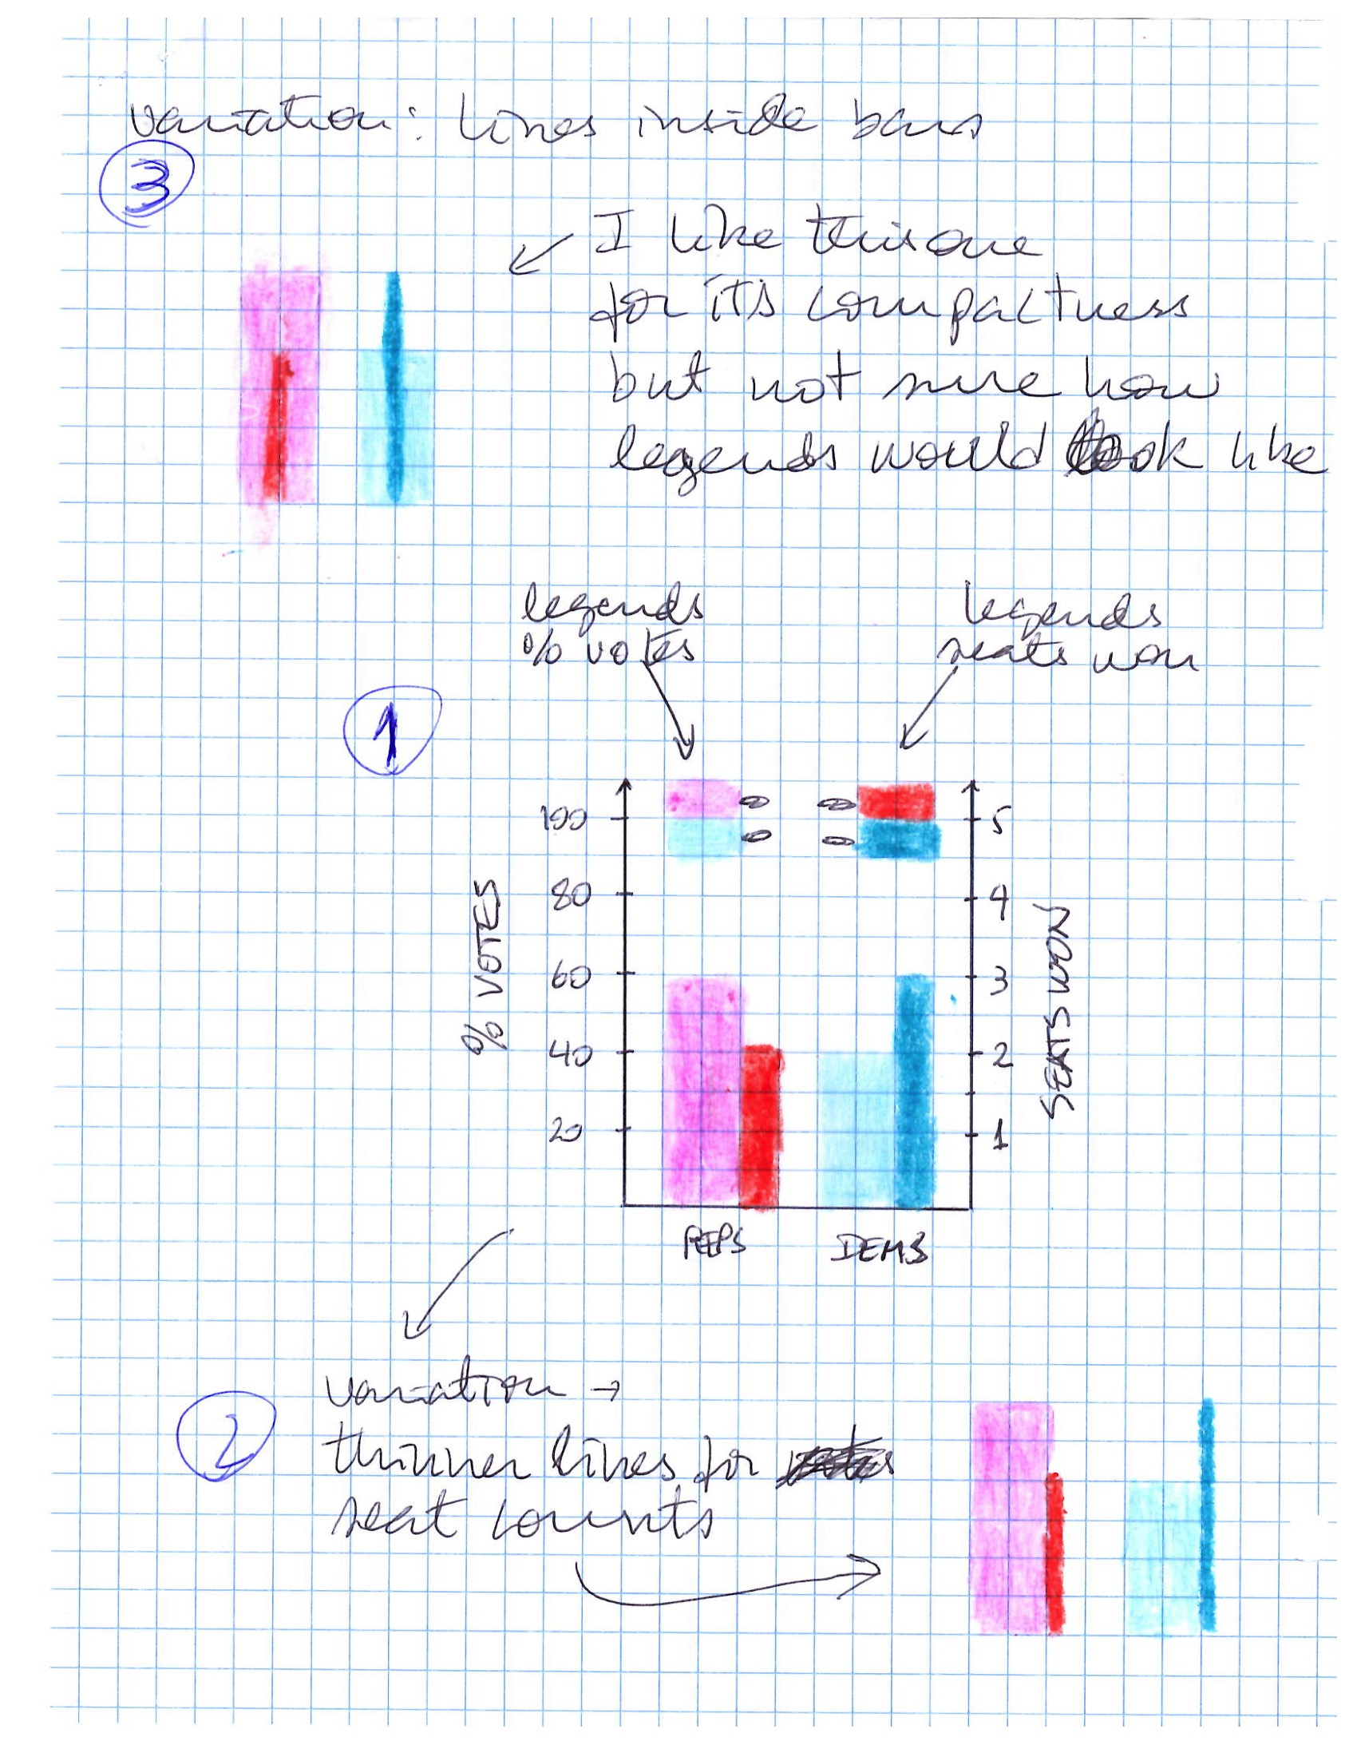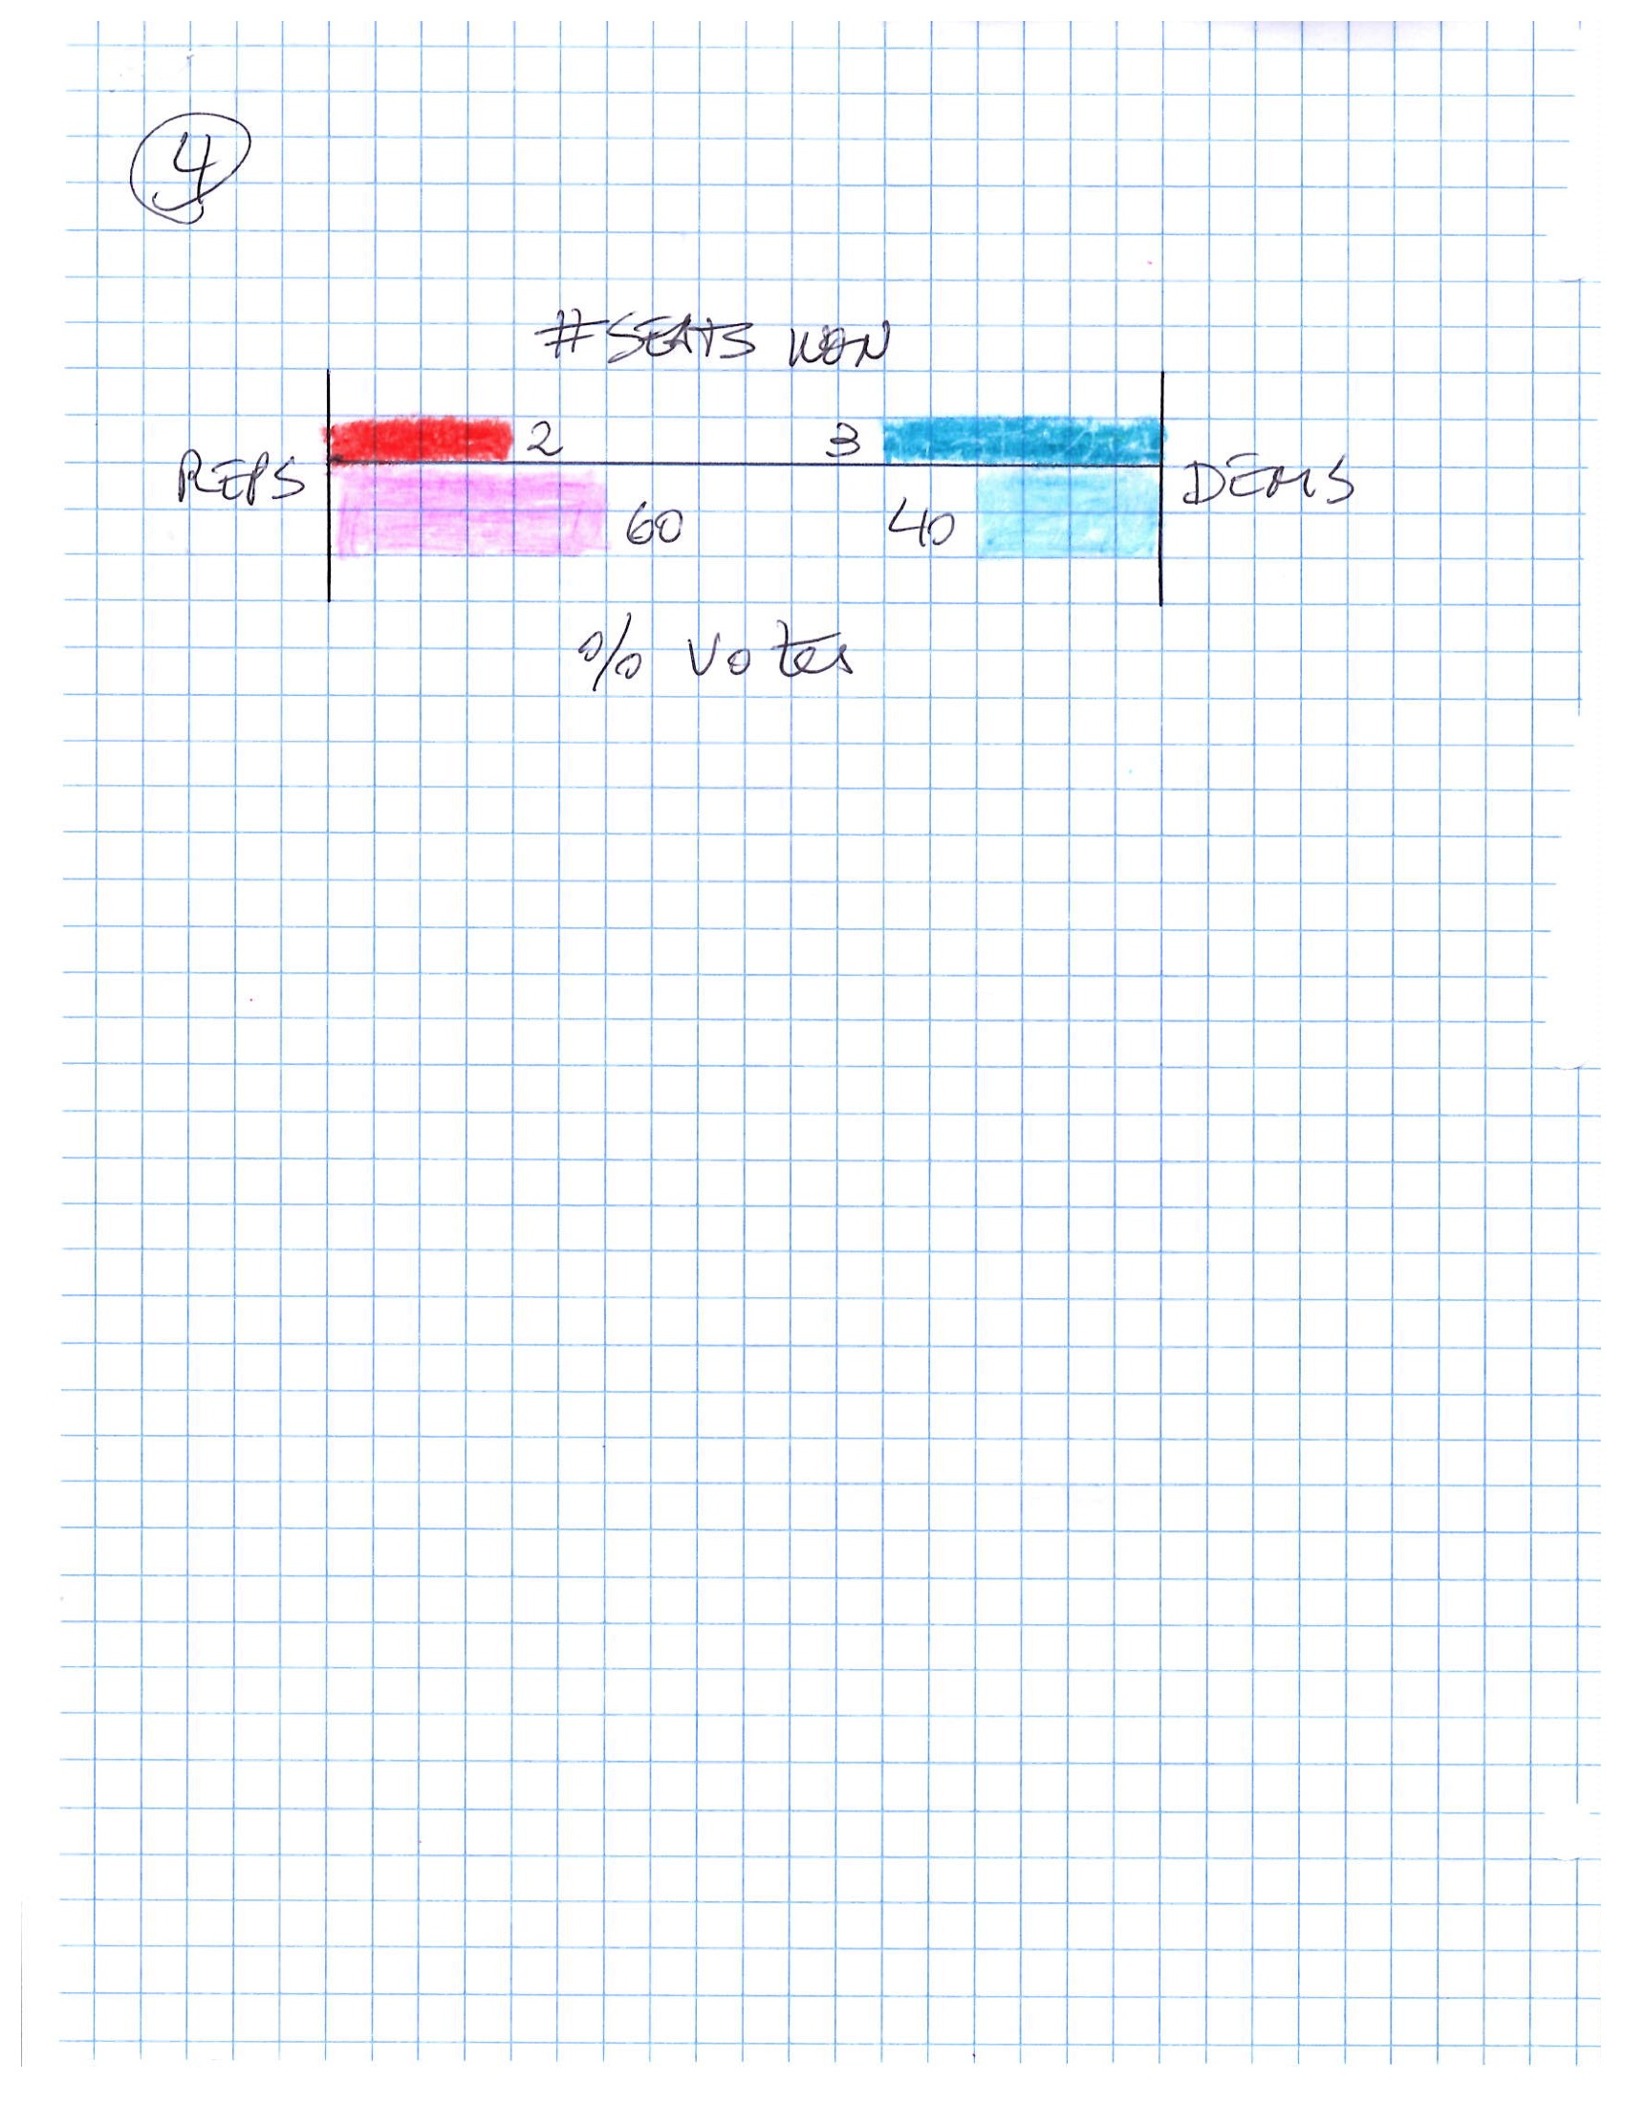

# Visualization Methods Selection

We mostly analyze categorical data that primarily falls into 3 categories (the “parties”[39]) and secondarily can be grouped by State (52 categories) or State and District (there were 435 districts at play in the 2016 election). When comparing different categories side by side (such as two parties) we considered scatter plots. However, bar charts proved more insightful for the analysis of “cracking” and “packing” and therefore were the plot of choice to show election results at the district level.

Scatter plots were the visualization of choice in a couple of instances where it was important to determine correlation between the lost seats in a state and other election result numbers, such as number of uncontested seats, or the efficiency gap metric.

We used maps to show state district lines and to situate the district numbers in the state map. Proper placement of the district numbers in the map was not always possible because many states have districts with curved shapes (e.g. “L-shaped”). Additionally, states with large urban areas have sometimes several small districts (in terms of area) bundled together in close proximity. It was not practical to include in our project maps that were large enough to allow visualization of district numbers in such cases. The urban areas around Los Angeles in California, and Houston in Texas are examples of areas with multiple small districts bundled close together in close proximity.

The key visualization for the project is a combination of three plots that show state map, votes per district, and total votes and seats won/loss by the major parties in a state election. The combined visualization brings together all the state information that we found insightful to investigate gerrymandering, given the data available for this project. Each component of the visualization was conceived separately at different phases of the project, but we realized later on that they belonged together. We described this visualization in detail in the prior section Project Unique Contributions. To the vast majority of states it worked very well, however it showed limitation for states with a large number of districts such as California and Texas. For these states, the plots need to be enlarged and displayed separately.

We selected a top-down approach to visualize gerrymandering, starting with US number of votes vs. seats won, and drilled down to a state level analysis. We developed a series of questions to guide our visualizations and ultimately tell a story that shows states where gerrymandering is *likely* at play, where it is likely *not* at play, where the efficiency gap metric works well as an indicator of gerrymandering, and where it doesn’t.

Based on our experience analyzing the project data using Jupyter Notebook and interacting with the various visualization we developed, we can envision a webpage that would allow users to explore issues of representation and gerrymandering interactively. Unfortunately, we did not have time to implement such interactive visualization.

# Results

Questions 1 – Where did the votes go?

Republican electors casted about 1% more votes than democrats in the 2016 House of Representatives election. Yet, they were able to elect about 24% more candidates than democrats.

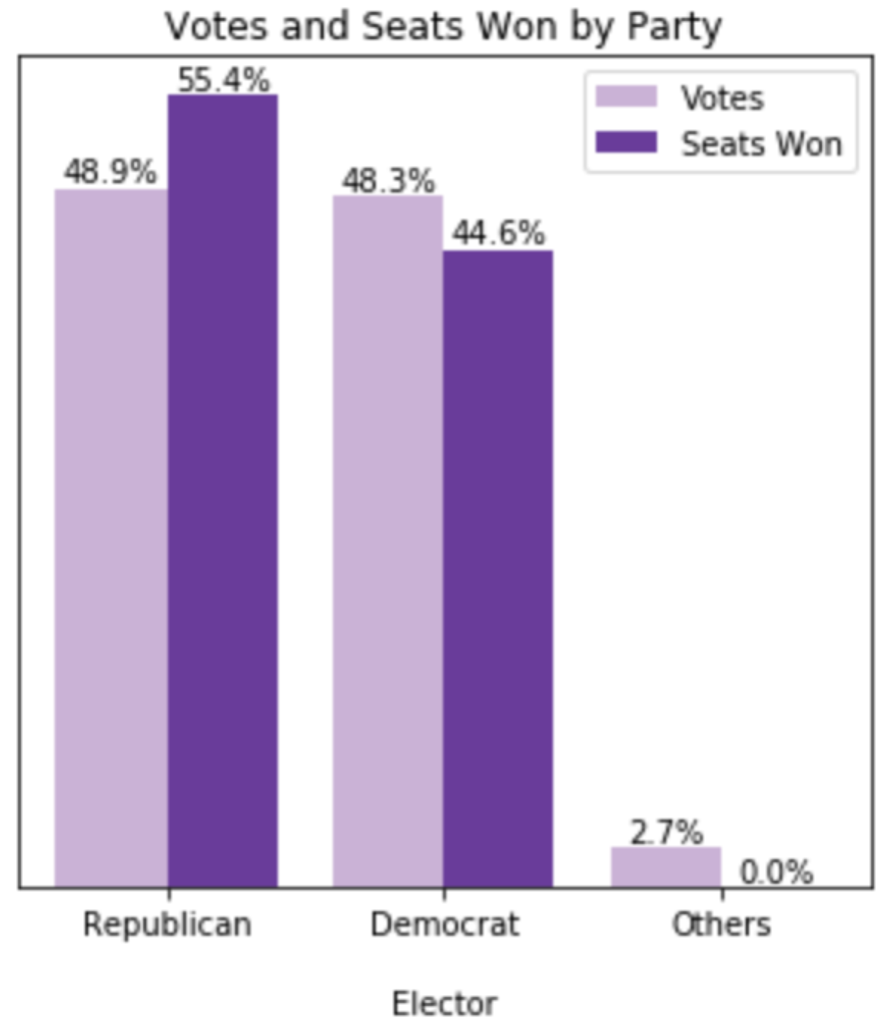

Question 2: Do republican electors have more power?

Power is defined by the Merriam-Webster as the "ability to act or produce an effect".34 On average, it took roughly 20% more Democrat electors to win a seat for their party, than it took Republican electors to elect a Republican candidate. In that sense, Republican electors had more power in the 2016 House of Representative elections. The next plot “More is less” shows that *more votes* to elect a candidate means *less power*.

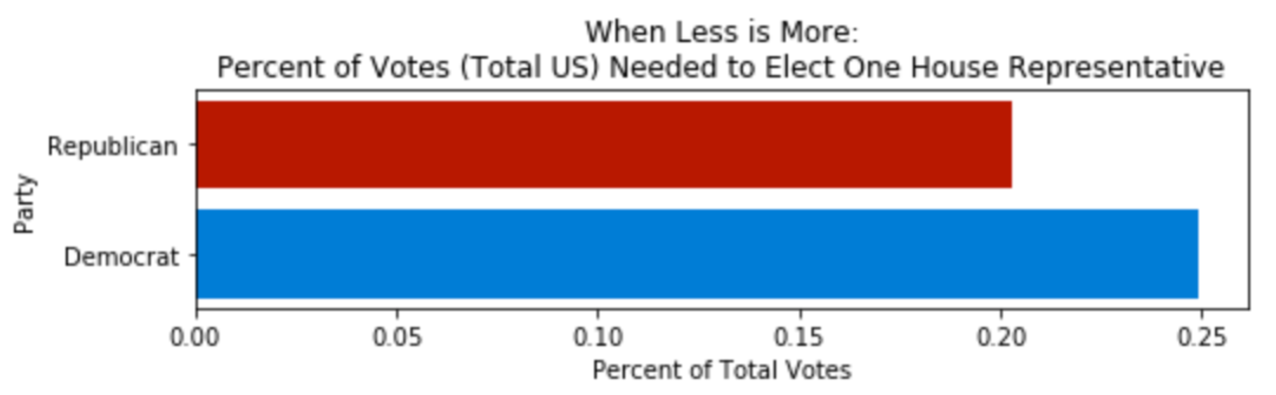

Question 3: How do state and national numbers compare?

Numbers at the state level reveal democrat electors needed more votes on average to elect their representatives to the House of Representatives than did republican electors. The horizontal lines on the plots below show the national average votes needed to elect a party candidate. We clearly see more blue bars with their tips above the line.

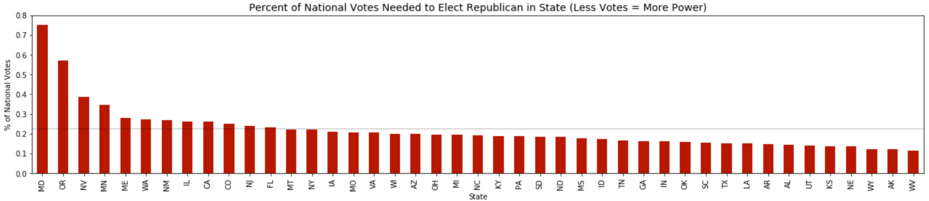

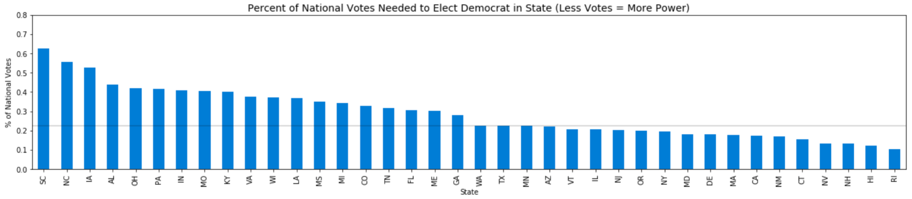

Question 4: How do party numbers compare at the state level?

The problem we saw with democrat electors needing to cast more votes to elect their candidates is made clearer when we look at party numbers side-by-side. Note that the states with a single bar for either party only had candidates elected from one party (e.g. ND, DE, MA, etc).

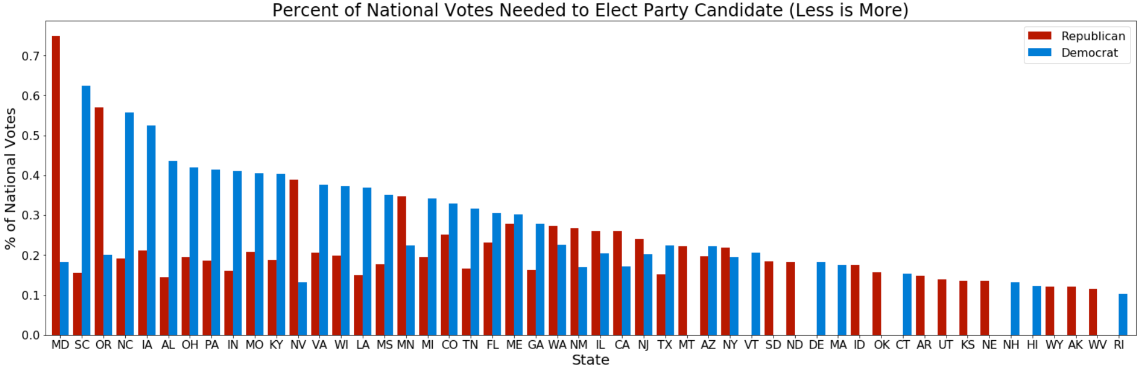

The scatter plot below, created from the same data used in the previous bar chart, highlights republicans have more power as they have more states in which democrats needed to cast more votes to elect their representatives. Only states that elected candidates from both parties are included in the scatter plot.

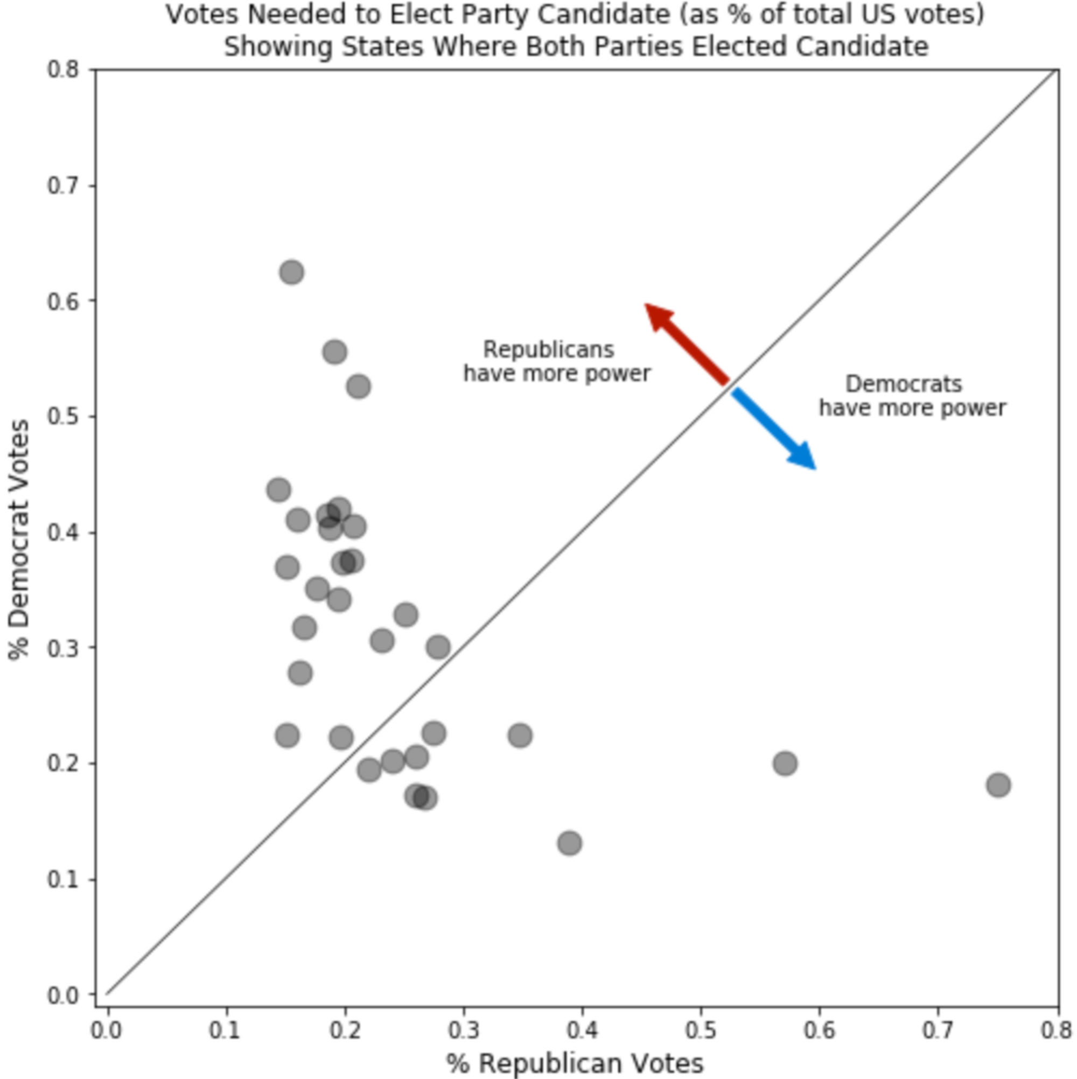

Question 5: How are votes cast in states where a party has extreme advantage?

By looking at the previous plots, we can identify many states where one of the two parties appears to have substantially more power. We now analyze 3 of them: Alabama, South Carolina and Oregon.

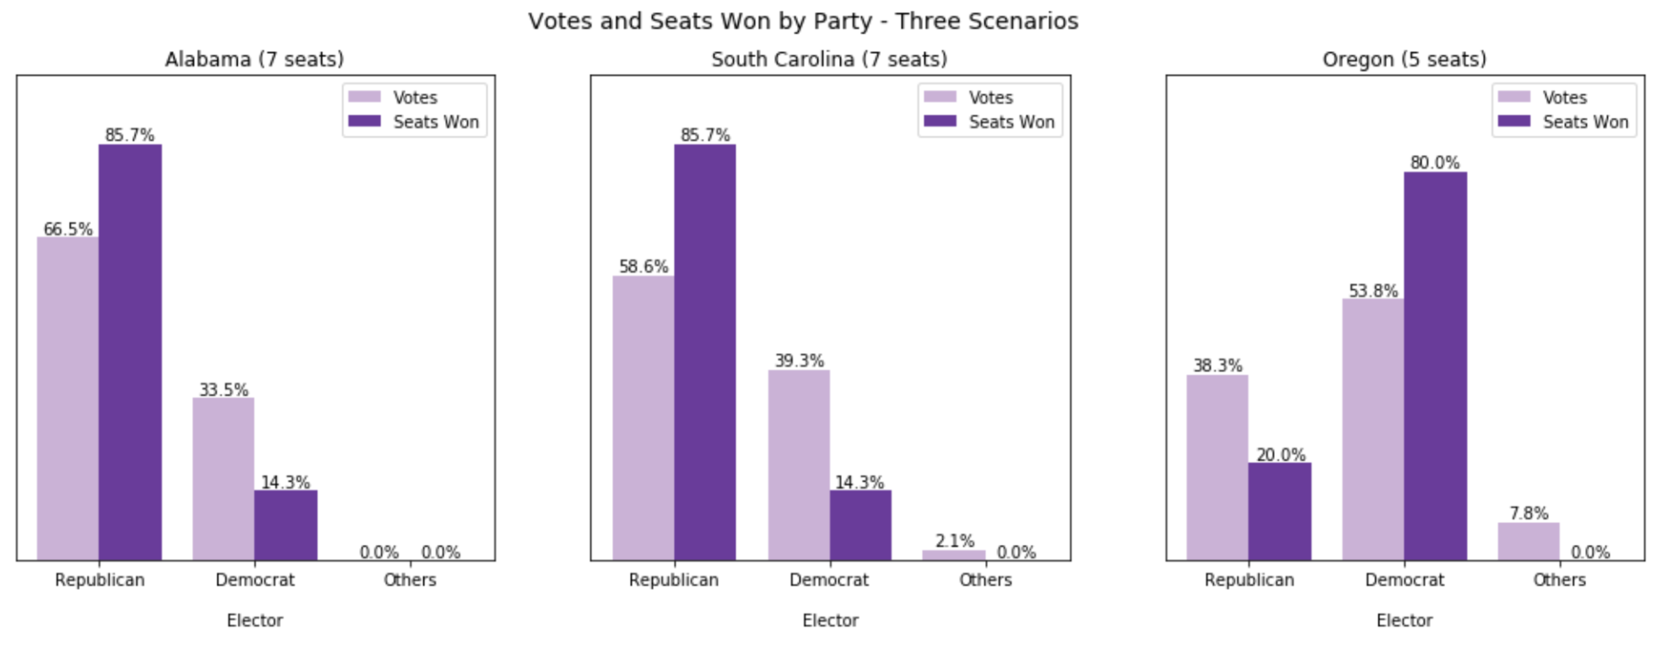

Alabama

Below we show the election results summary for Alabama. The proportion of democrat votes is enough to grant two seats to democrats but they won one seat only.

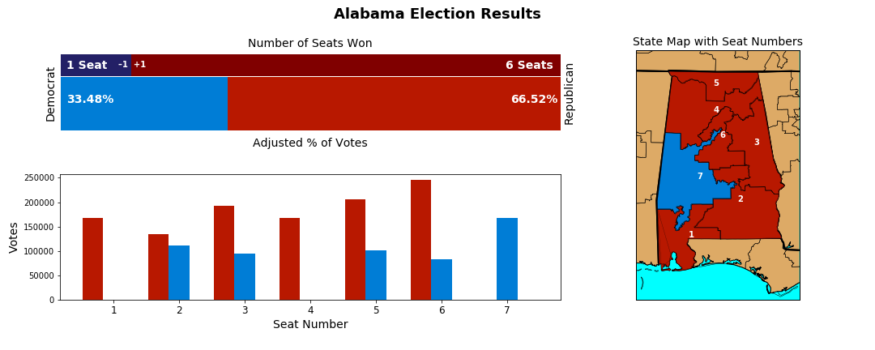

Gerrymandering could be the reason for the democrat’s lost seat, as explained in the section Project Unique Contributions above.

South Carolina

Below we show the election results summary for South Carolina. The proportion of democrat votes is enough to grant two seats to democrats but they won one seat only.

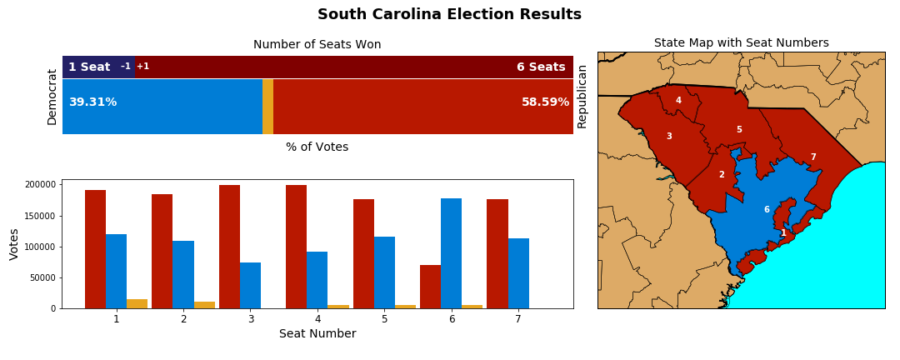

Gerrymandering could be happening in South Carolina, specifically “cracking”, since many blue votes are suspiciously spread thin across several adjacent districts. Packing of blue votes in district 6 favors red win in district 1. Note the wiggly shape of district lines delineating districts 1, 2 and 6.

Oregon

Below we show the election results summary for Oregon. The proportion of votes cast by republicans is just short (38.32% vs. 40%) of allowing republicans to claim the right to one more seat in the state.

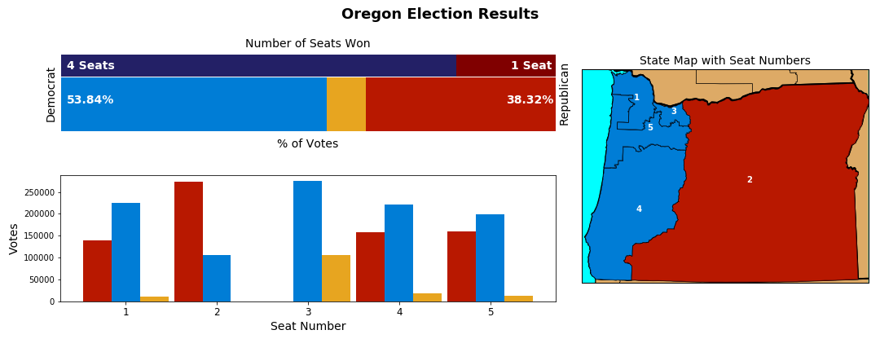

Unlike Alabama and South Carolina, Oregon shows a stronger presence of a third party. The presence of a third party complicates the analysis of gerrymandering. We don’t know if the strong presence of a third party is not, in itself, a symptom of carefully crafted district lines intentionally drawn to favor one of the major parties (through the splitting of votes for the opposing party). In Oregon, red votes are diluted across districts 1, 4 and 5, which are adjacent. But perhaps due to a strong third party in district 3, republicans did not cross the 40% vote threshold to deserve a second seat. The fact that republican votes are close to the threshold accounts for the disproportional balance of power in the state, heavily in favor of democrats. Republicans casted *almost* enough votes to win two seats but were able to convert these votes into a one seat win only.

Question 6: Can the efficiency gap expressed as lost seats help identify gerrymandering?

Nicholas O. Stephanopoulos and Eric M. McGhee in their article Partisan Gerrymander-ing and the Efficiency Gap, in which they create the Efficiency Gap metric, suggest a threshold to identify gerrymandering. They "recommend setting the bar at two seats for congressional plans and 8 percent for state house plans"[40]. Below we list states where a party “lost” one or more seats.

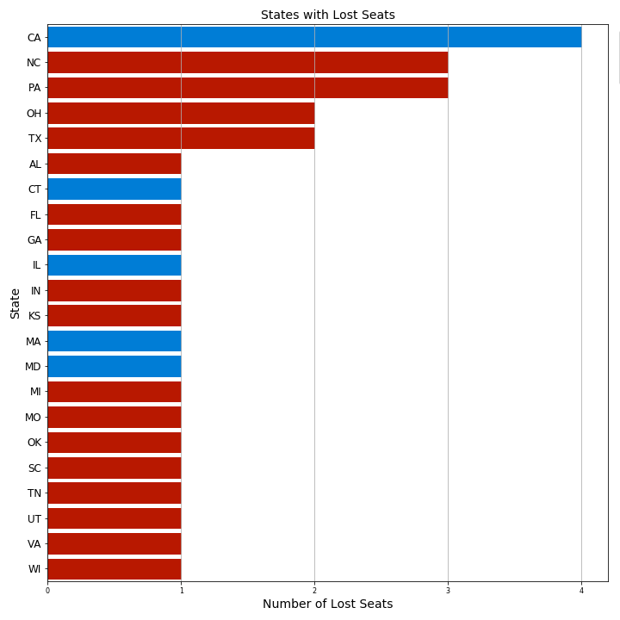

Notice that Oregon does not appear in the list because republicans needed to cross the 40% vote threshold to deserve winning a second seat.

Based on the 2-seat criterion, the following states would be gerrymandered states: California, North Carolina, Pennsylvania, Ohio and Texas. We will not analyze California (56 districts) and Texas (36 districts) because the number of lost seats in these states (4 and 2 respectively) is a small percentage of their total district numbers.

North Carolina

Below we show the election results summary for North Carolina. The proportion of democrat votes is enough to grant six seats to democrats but they won three seats only.

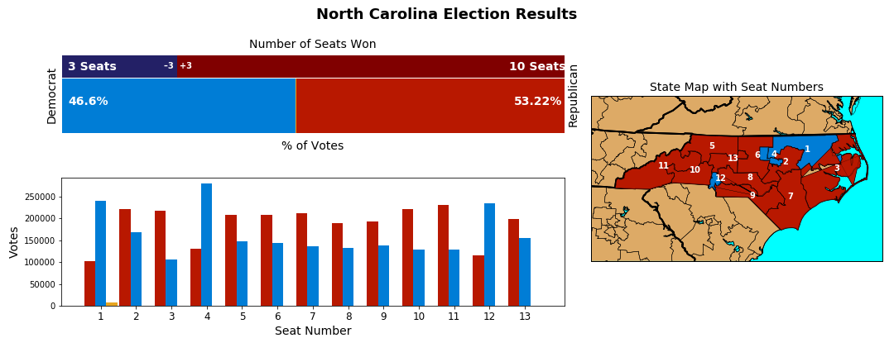

North Carolina shows significant number of blue votes spread evenly across districts 5 through 11 indicating that “cracking” could be at play. Districts 1, 4 and 12 appear to show “packing” of blue votes. Considering the irregular shape of district lines in this state, it is likely that gerrymandering is the reason why democrats could only convert half of their votes into district wins.

Pennsylvania

Below we show the election results summary for Pennsylvania. The proportion of democrat votes is enough to grant eight seats to democrats but they won five seats only.

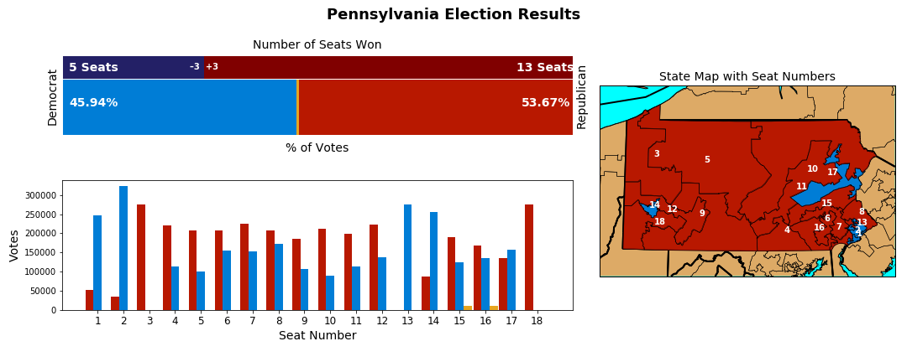

Here is another state, like North Carolina, where we see three typical indicators of possible gerrymandering: “cracking” of blue votes across many districts (e.g. 4-12), “packing” of blue votes in four districts (1, 2, 13 and 14), and squiggly district lines.

Ohio

Below we show the election results summary for Ohio. The proportion of democrat votes is enough to grant six seats to democrats but they won four seats only.

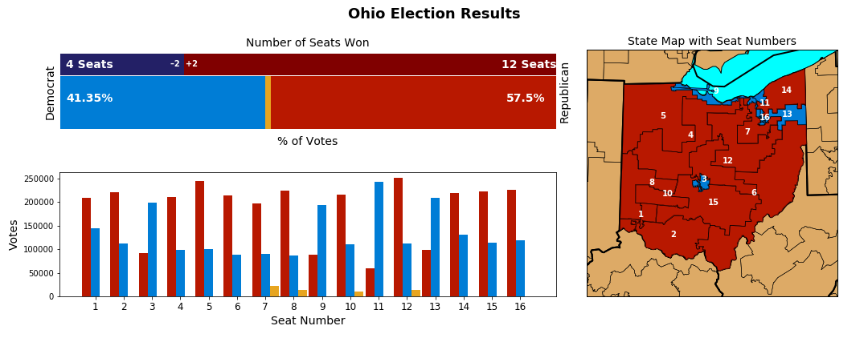

The evidence of gerrymandering is less pronounced in Ohio when compared to Pennsylvania, despite the irregular district lines in the state. There is some “cracking” of blue votes but many of the districts where that could be occurring don’t show a strong presence of blue votes (e.g. districts 4-7). Only district 11 shows a clear case of “packing” of blue votes.

It is noteworthy that as the number of districts in a state increases, it becomes harder to qualitatively evaluate gerrymandering with the visualization tools and the data at our disposal. We can appreciate this difficulty by looking at the election summary results for Texas, which has 36 districts. The efficiency gap metric based on number of lost seats is of little help.

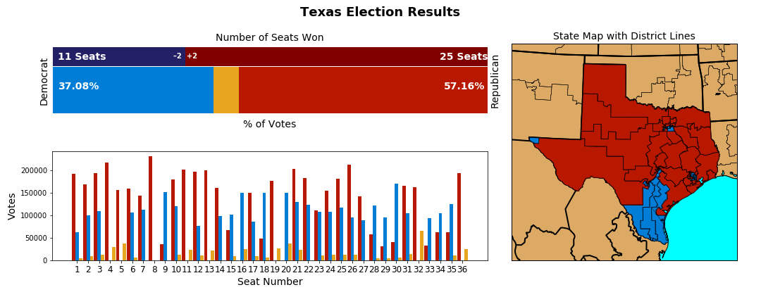

Larger plots for the states of Texas are included in appendix B.

Perhaps a better metric to help identify gerrymandering based on lost seats would take into account the total number of seats in the state. With that in mind, below we explore the percentage of seats lost, rather than the count of seats lost. Only states with one or more lost seats are included.

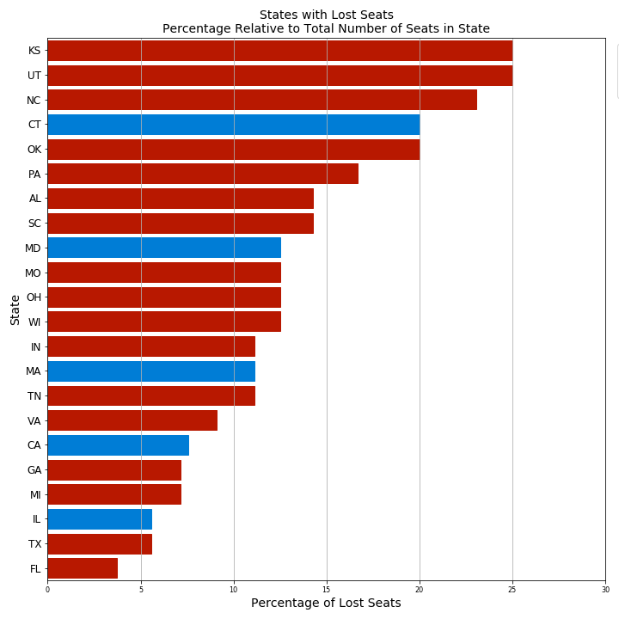

We will analyze the states that have 20% or more of their seats disproportionally won by one of the parties: Kansas, Utah, North Carolina, Connecticut, and Oklahoma. We note that from this list, democrats were the favored party in Connecticut only.

Kansas

Below we show the election results summary for Kansas. The proportion of democrat votes is enough to grant one seat to democrats but they won zero seats.

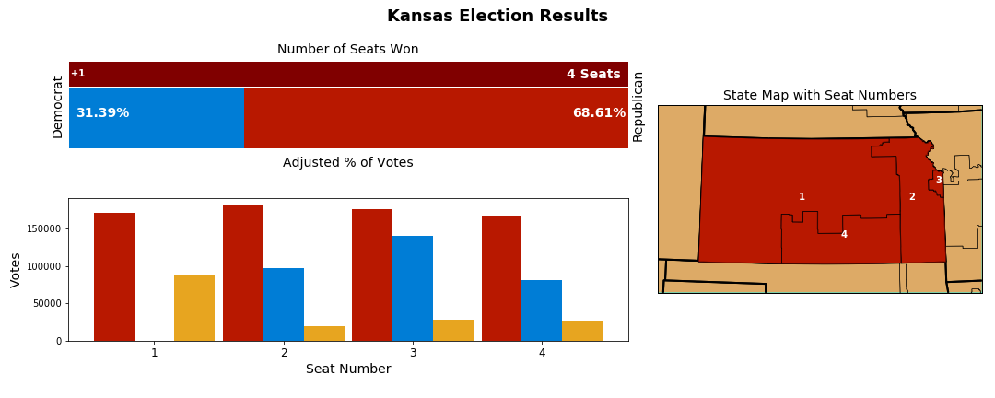

It is possible that blue votes in district 2 are close enough to district 3 boundaries to indicate gerrymandering. But that is unlikely. One could argue that turning district 3 blue might in itself require gerrymandering to favor the minority party. This case seems to be an example of how the single member district (SMD) voting system can favor a party irrespective of gerrymandering.

Utah

Below we show the election results summary for Utah. The proportion of democrat votes is enough to grant one seat to democrats but they won zero seats.

It could be argued that district 4 could have been shaped differently to include more democrat electors, so democrats would win one seat. But, like Kansas, this state seems to be another example of how the SMD voting system can favor a party irrespective of gerrymandering.

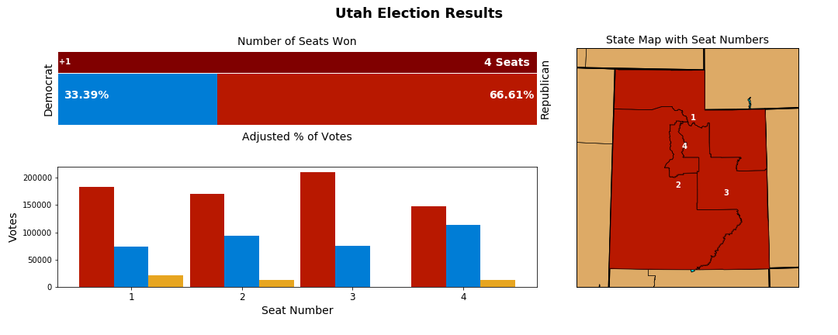

North Carolina

Please refer to previous discussion on North Carolina.

Connecticut

Below we show the election results summary for Connecticut. The proportion of republican votes is enough to grant one seat to republicans but they won zero seats.

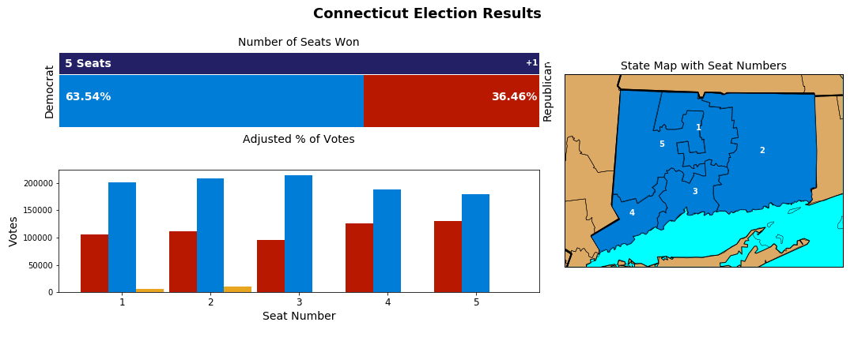

Connecticut shows republican votes diluted across all districts in the state. The irregular shape of the state districts (particularly district 4) is suspicious and suggests gerrymandering could be at play favoring the Democratic Party.

Oklahoma

Below we show the election results summary for Oklahoma. The proportion of democrat votes is enough to grant one seat to democrats but they won zero seats.

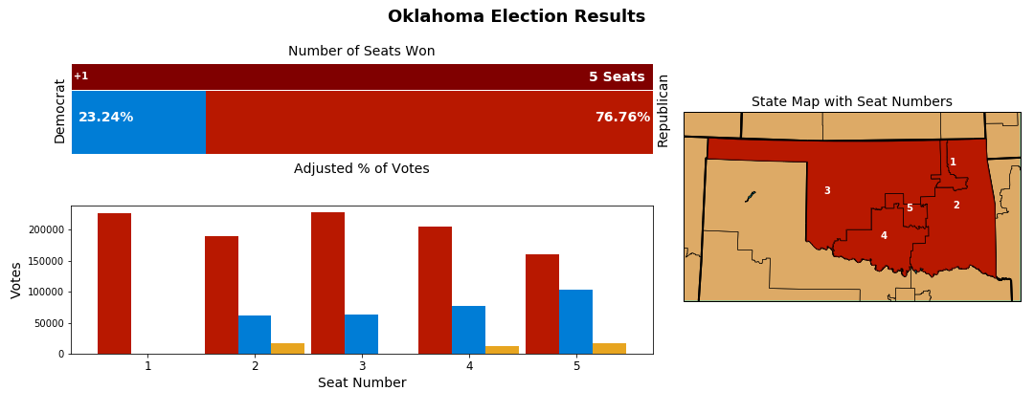

Oklahoma appears to follow the pattern of Utah and Kansas. It could be argued that district 5 could have been shaped differently to include more democrat electors, so democrats would win one seat. But, like Utah and Kansas, it is reasonable to say this is another example of how the SMD voting system can favor a party irrespective of gerrymandering.

Question 7: Can the efficiency gap percentage metric help identify gerrymandering?

Here we explore the efficiency gap percentage metric, which is computed as the ratio between balance of wasted votes and total votes in the state.

For calculation of wasted votes, the following method was used:

* All votes for winning party beyond simple majority are considered wasted votes.
* All votes for losing party are considered wasted votes.

As stated before in the section Efficiency Gap Computation it is important to keep in mind that other methods to calculate wasted votes are possible. The methods will differ in the way they compute wasted votes for uncontested districts. For example, one could impute votes for the losing party based on past elections; or, one could speculate a percentage of votes that would have been cast for an opposing losing candidate (e.g. 25%), had there been one in the ballot. In this project, we considered zero wasted votes for the losing party in uncontested districts.

The state of Oklahoma demonstrates the limitations of the efficiency gap percentage metric for congressional elections. Note that the efficiency gap shows the Democratic Party as favored but democrats did not win a single seat in Oklahoma, so the party couldn’t have benefited from gerrymandering. The reason for the issue is related to the calculation of wasted votes; the number of red wasted votes was higher than the number of blue votes overall (all losing votes), so the efficiency gap percentage calculation shows democrats as benefiting from gerrymandering.

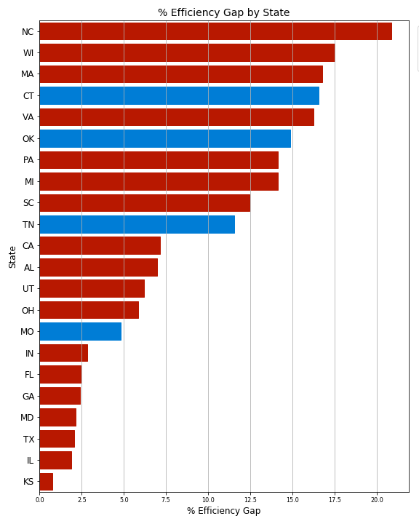

Since there is no recommendation for a percentage threshold to identify gerrymandering for congressional races we looked for a correlation between the percentage efficiency gap and the percentage of lost seats in a state. We found no significant correlation therefore we don’t explore percent efficiency gap further.

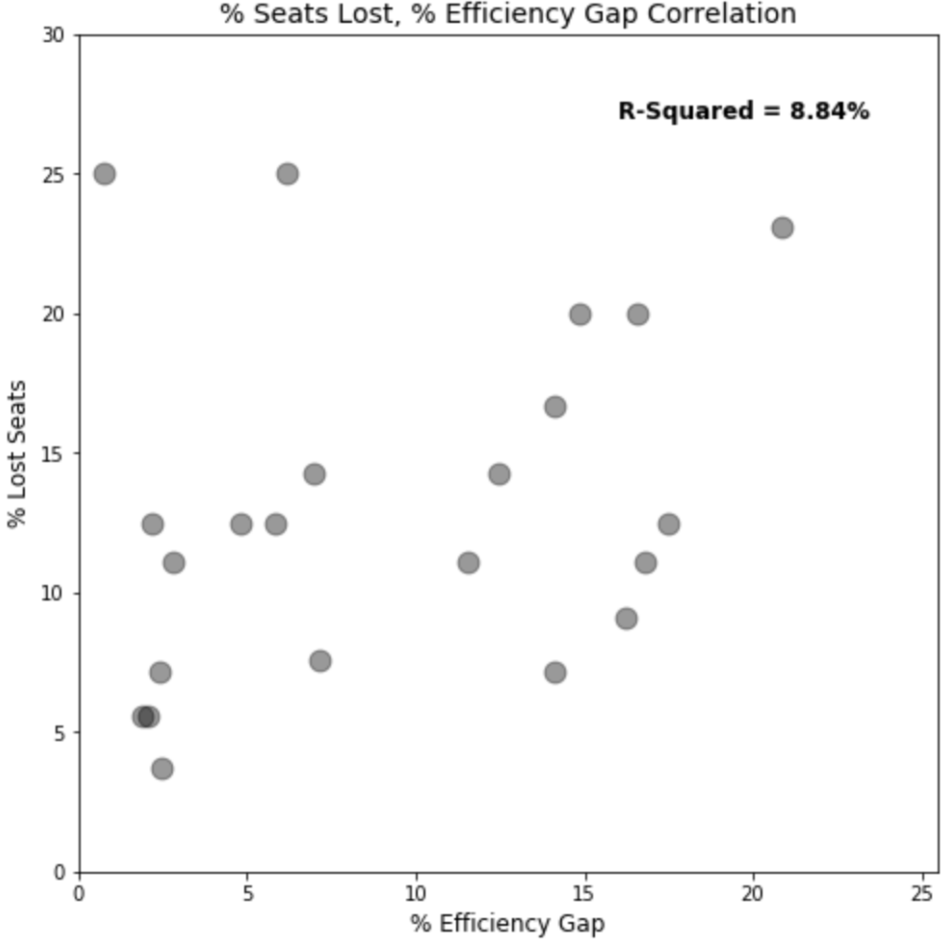

Question 8: Can the number of uncontested seats help identify gerrymandering?

Packing is one important indicator of gerrymandering. Packing can lead to uncontested districts, as repeated losses will discourage electors and potential candidates from one of the parties. We explored the correlation between percentage of uncontested districts and the percentage of lost seats in states with one or more lost seats. We found no significant correlation between the two and so we won’t explore percent of uncontested districts as an indicator of gerrymandering.

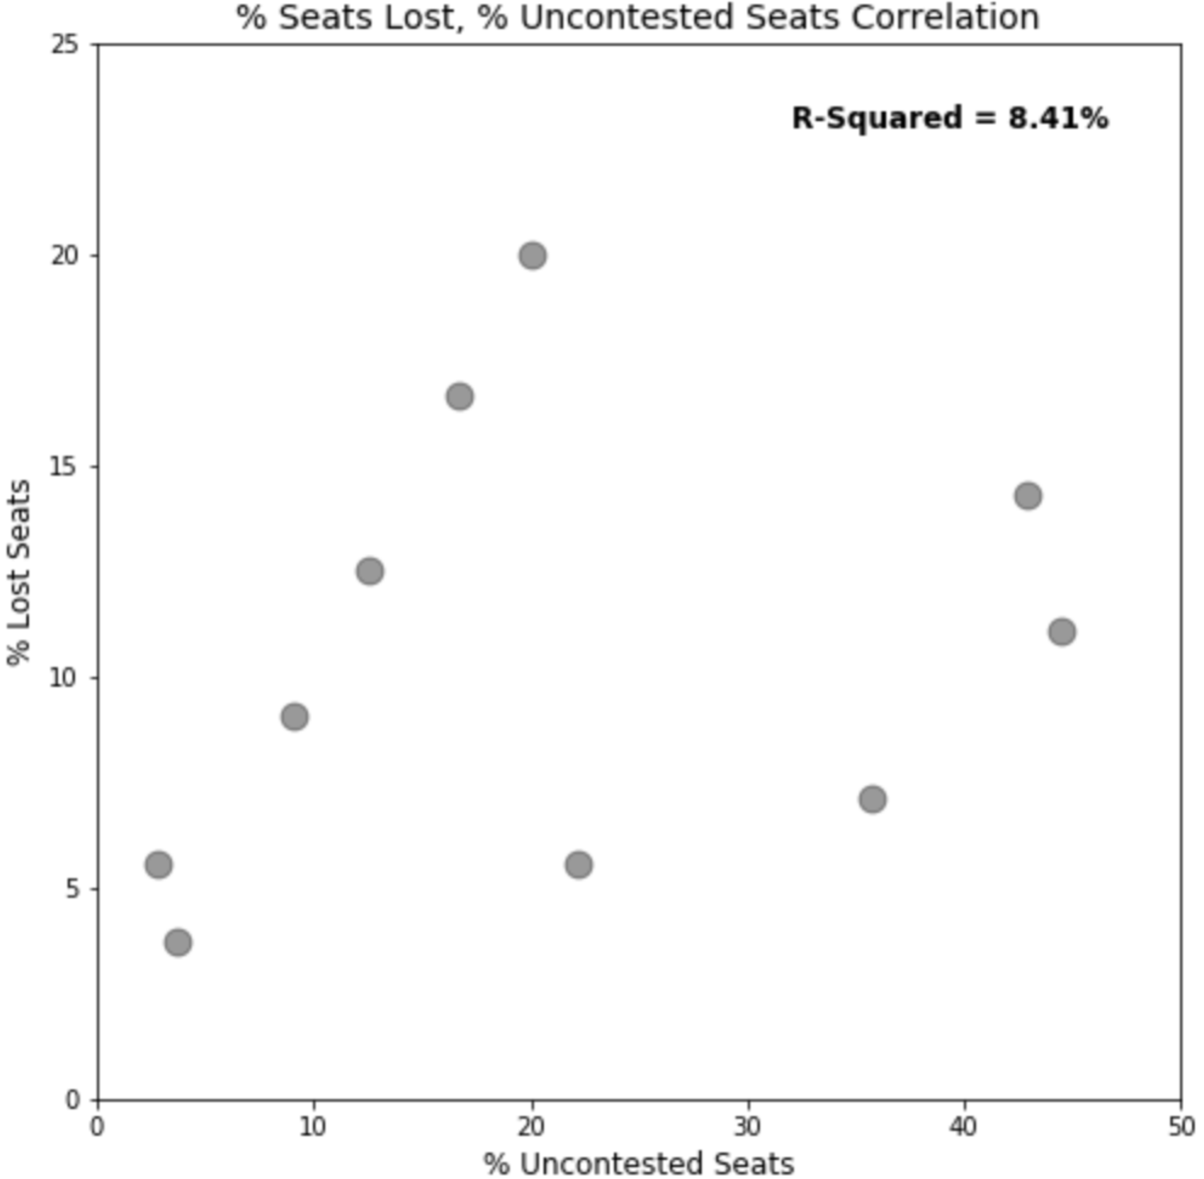

Question 9: Can the shape of district lines alone help identify gerrymandering?

We have seen that in many states it is possible to support claims of gerrymandering by examining district boundaries. Irregular district shapes and squiggly district lines suggest gerrymandering could be at play. But below we show two examples of states with very irregular district lines in which election results were proportional to votes cast. Hence, district lines alone won’t suffice to support claims of gerrymandering and, when we look at irregular district lines to support gerrymandering claims, we need to keep in mind that patterns of population distribution and concentration in certain areas, typically urban areas, rather than spurious interests could be the reason for the suspicious shape of states’ districts.

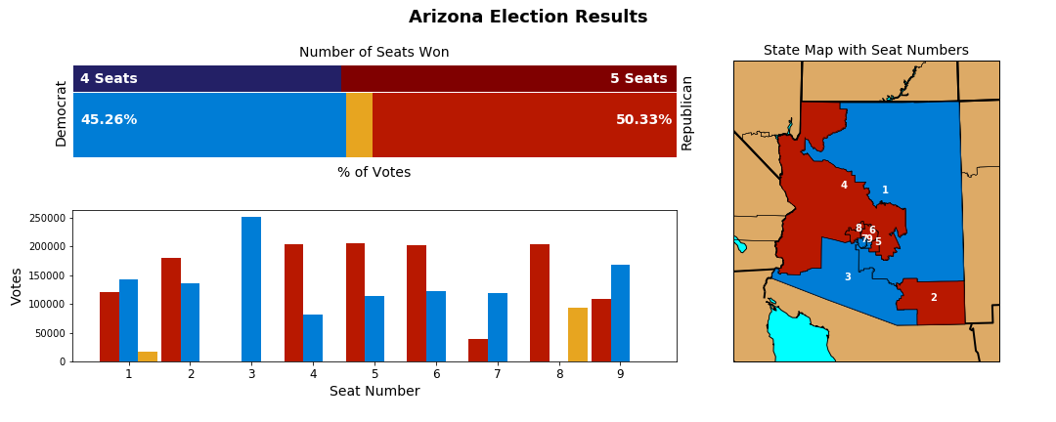

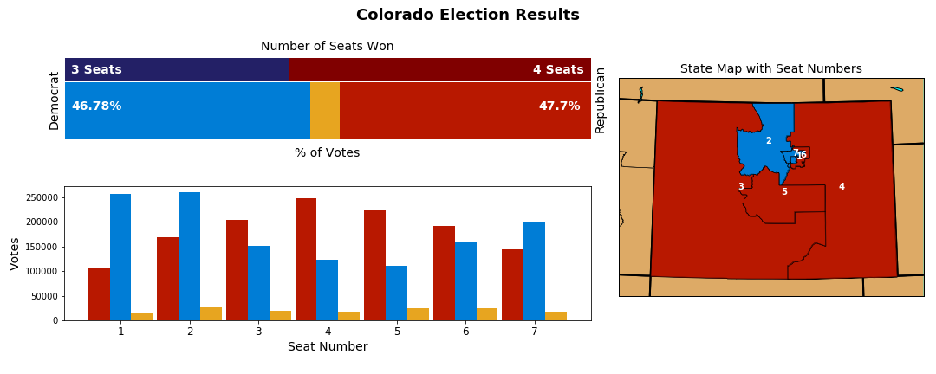

Question 10: Can we rule out gerrymandering if election results are proportional?

Nebraska is a good example of a state that could possibly be gerrymandered but in which election results were proportional to voting numbers. Notice democrats were close to the 33% threshold that would lead us to put this state in the group of states where a party lost one seat. It is possible however that blue voters were “cracked” between districts 1 and 2 to prevent a blue win of one seat in the state, even if more blue voters showed up in district 1. More data consisting of population numbers and demographics in the areas adjacent to district 2 boundaries would be needed to support any claims of gerrymandering.

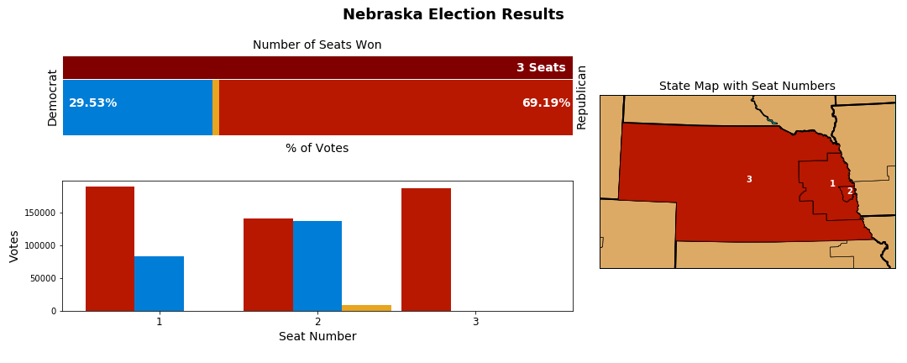

Question 11: How many seats were lost by SMD vs. possible gerrymandering?

Below we classify all states with lost seats into two groups: SMD or gerrymandering, based on our assessment of the likelihood the cause of the lost seats in that state is the SMD or gerrymandering. The visualizations used for this analysis can be found in Appendix A. When analyzing packing we discounted the fact that high concentration of blue voters in small districts around larger urban centers is difficult to void.

States in which democrats were favored:

|  |  |  |  |  |  |
| --- | --- | --- | --- | --- | --- |
| **State** | **Number of seats won?** | **Evidence of cracking?** | **Evidence of packing?** | **Wiggly district lines?** | **Most likely: SMD or Gerrymandering?** |
| CA | 4 | No | No | Yes | SMD |
| CT | 1 | Yes | No | Yes | Gerrymandering |
| IL | 1 | Yes | Yes | Yes | Gerrymandering |
| MA | 1 | Little | No | Yes | SMD |
| MD | 1 | Yes | Yes | Yes | Gerrymandering |

States in which Republicans were favored:

| **State** | **Number of seats won?** | **Evidence of cracking?** | **Evidence of packing?** | **Wiggly district lines?** | **Most likely: SMD or Gerrymandering?** |
| --- | --- | --- | --- | --- | --- |
| NC | 3 | Yes | Yes | Yes | Gerrymandering |
| PA | 3 | Yes | Yes | Yes | Gerrymandering |
| OH | 2 | Yes | Yes | Yes | Gerrymandering |
| TX | 2 | Some | Some | Yes | SMD |
| AL | 1 | Yes | Yes | Yes | Gerrymandering |
| FL | 1 | Some | Some | Yes | SMD |
| GA | 1 | Yes | Yes | Yes | Gerrymandering |
| IN | 1 | Yes | Yes | Yes | Gerrymandering |
| KS | 1 | Some | No | No | SMD |
| MI | 1 | Some | Some | Yes | SMD |
| MO | 1 | No | No | Yes | SMD |
| OK | 1 | Some | No | Yes | SMD |
| SC | 1 | Yes | Yes | Yes | Gerrymandering |
| TN | 1 | Some | Some | Yes | SMD |
| UT | 1 | Yes | Yes | Yes | Gerrymandering |
| VA | 1 | Yes | Yes | Yes | Gerrymandering |
| WI | 1 | Yes | Yes | Yes | Gerrymandering |

In summary, of a total of 31 combined seats lost by both parties, 58% of them were lost by possible gerrymandering, per our best judgment. Republicans were favored by possible gerrymandering in 65% of the time, while democrats were favored only 38% of the time. Close to half of the total number of seats lost by either party was mostly due to the SMD voting system.

# Summary of Findings

The following is a summary of our findings based on the answers to the above ten questions:

* For the most part republicans electors have more power than democrat electors, since they need to cast less votes to elect their representatives (Questions 1-4).
* In states where a party has significant more power, the reason could be gerrymandering, the SMD voting system, or the presence of a strong third party (Question 5).
* The efficiency gap threshold of 2 lost seats helped identify 2 likely cases of gerrymandering – North Carolina and Pennsylvania – and one less likely case – Ohio (Question 6).
* The efficiency gap threshold of 2 lost seats is not helpful for states with a large number of districts, such as California and Texas (Question 6).
* The efficiency gap threshold expressed as a *percentage of lost seats* is not a good indicator of gerrymandering, since it singled out many states – Kansas, Utah and Oklahoma – where the election disproportional results are most likely caused by the SMD electoral system, rather than gerrymandering (Question 6).
* The efficiency gap metric expressed as a *percentage of wasted votes* does not help identify likely gerrymandered states (Question 7).
* The *percentage of uncontested seats* does not help identify likely gerrymandered states (Question 8).
* Irregular district shapes and squiggly district lines, as seen in Arizona and Colorado, are not sufficient evidence to support claims of gerrymandered (Question 9).
* We should not rule out the possibility that a state is gerrymandered based on proportional election results, as demonstrated by Nebraska (Question 10)
* Of 31 total combined seats lost by both parties, 58% we them were lost by possible gerrymandering. Republicans were favored by possible gerrymandering 65% of the time, and democrats 38%. (Question 11).

# Conclusion

In light of the representational imbalance observed in the US House of Representatives, our project aimed at examining first, if the cause of such imbalance could be attributed to gerrymandering and second, if the efficiency gap could be deemed a good metric to identify gerrymandering.

Our research showed several cases in which representation imbalance happen at the state level most likely due to the Single Member District (SMD) voting system (e.g. Utah, Kansas, Oklahoma), rather than gerrymandering. But a tally of all states where seats were lost indicates that in the majority of cases (58%) gerrymandering rather than the SMD is the most likely cause of representation imbalance in the US House of Representatives. Republicans appear to have been favored by gerrymandering 65% of the time in the states where they won seats in excess of the proportion of their votes, while democrats were favored by gerrymander only 38% of the time.

The efficiency gap metric proved to be a poor classifier of gerrymandering. The metric is unavoidably biased since it requires a subjective decision in the computation of wasted votes for uncontested districts. Additionally, the 2-seat threshold proposed by the inventors of the metric doesn’t take into account the number of districts in a state. So, states like Texas with 36 districts get the same rating by the metric – 2 lost seats – as Ohio, which has 16 seats. Consequently, it became clear in our project that, given the data at our disposal, subjective judgment would always be the ultimate arbitrator of how likely state election results were affected by gerrymandering.

The visualizations we created for the project proved very insightful. Particularly the one that combined in a single visualization the plot showing lost seats vs. proportion of party votes, along with votes per district and state district map. We believe the visualizations used in our project offer a good blueprint for a future online interactive visualization.

In conclusion, our research indicates it is very likely that gerrymandering favoring the Republican Party is the main cause of the representation imbalance in the US House of Representatives. To reach this conclusion we relied heavily on qualitative analysis because the efficiency gap proved to be a poor metric to assess gerrymandering in congressional elections.

# Appendix A

States where democrats were favored

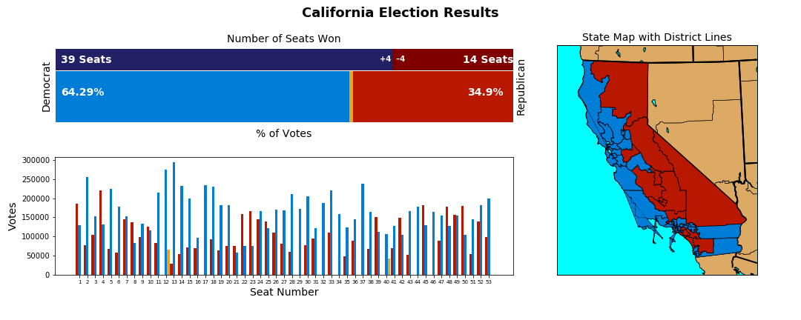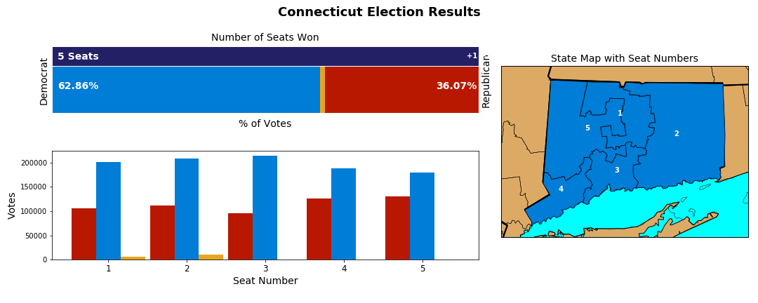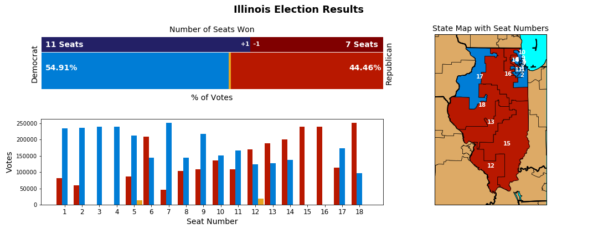

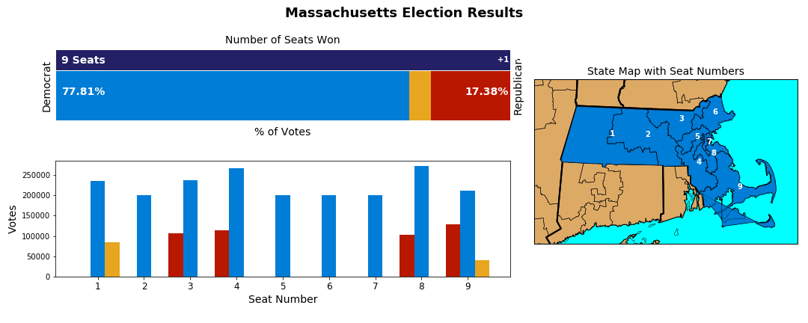

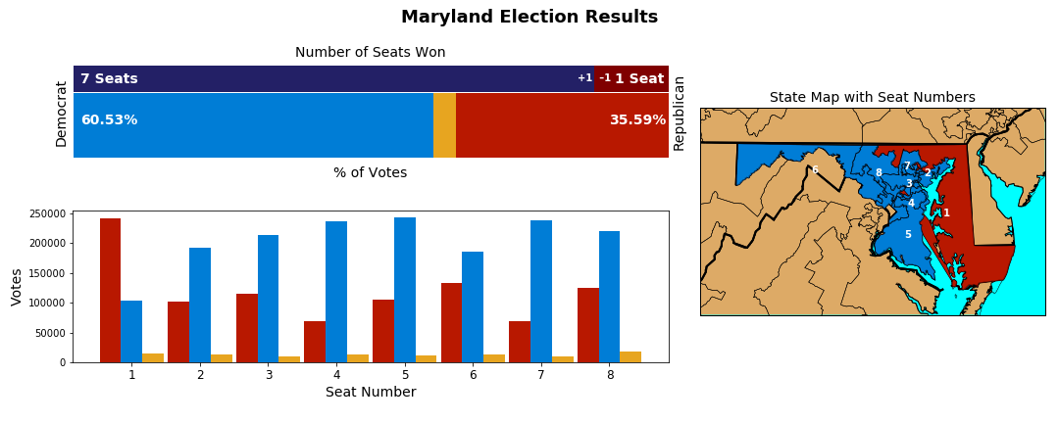

States where republicans were favored











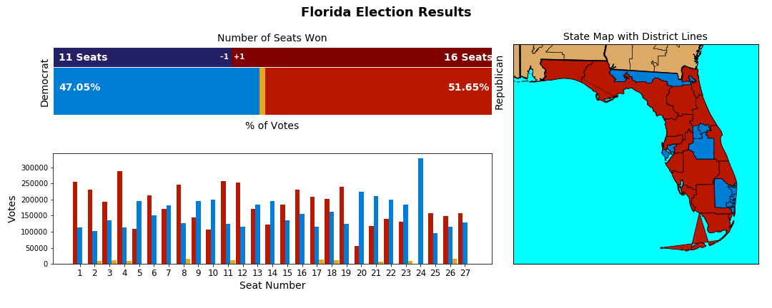

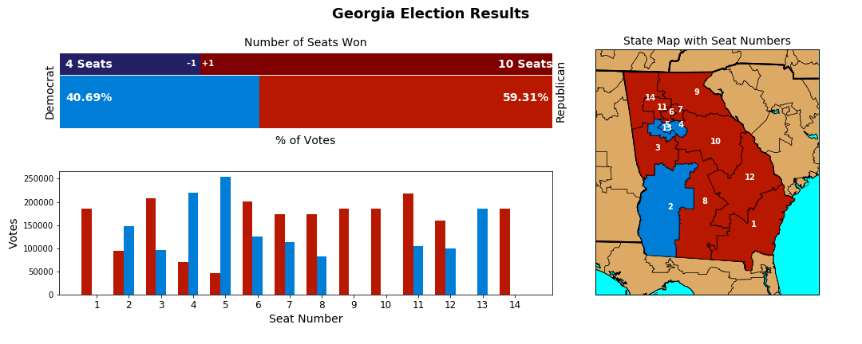

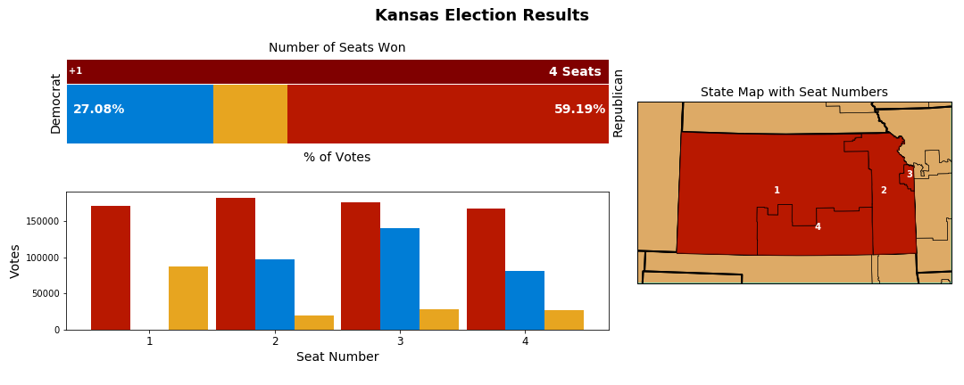

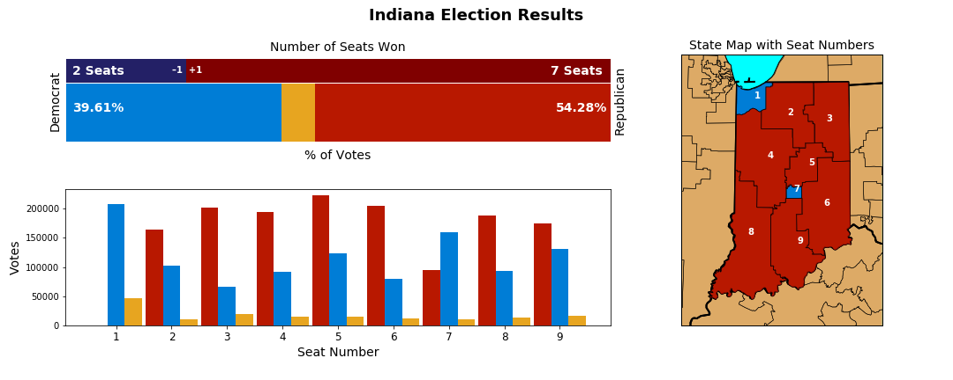

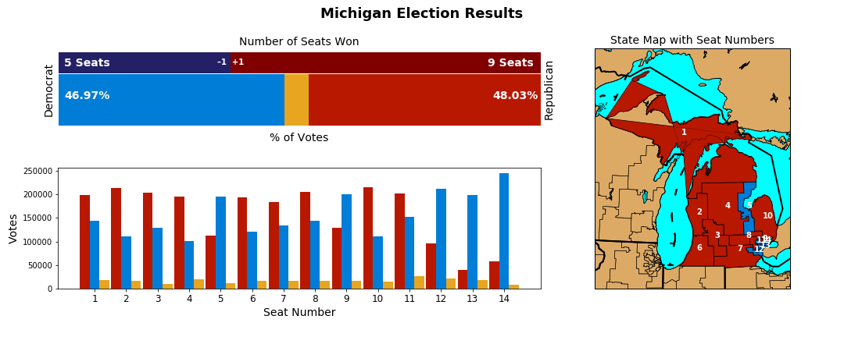

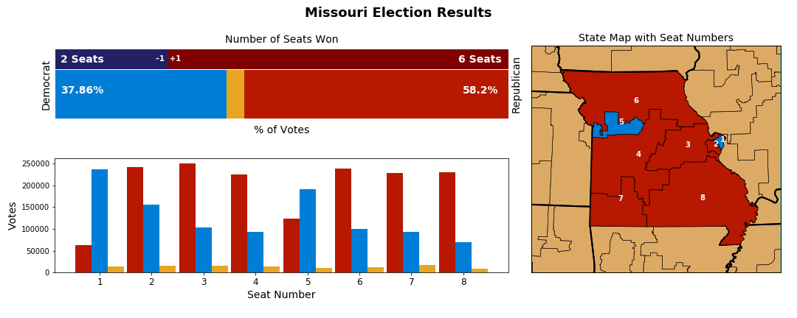

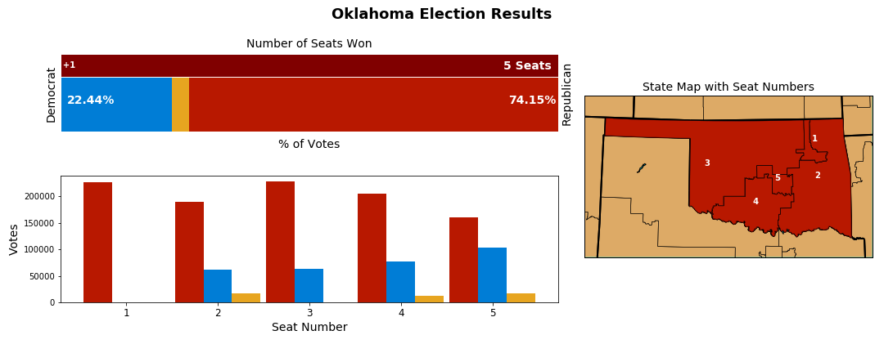



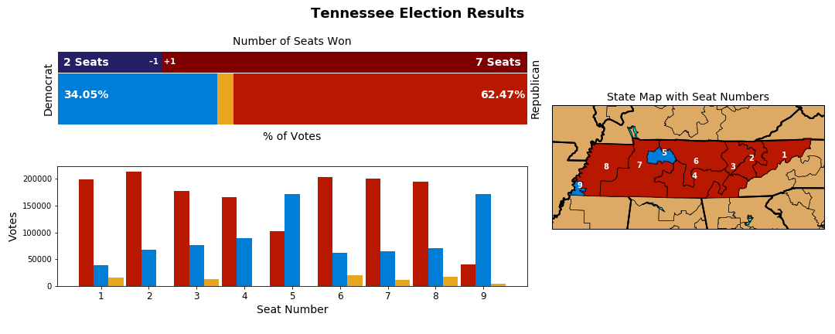

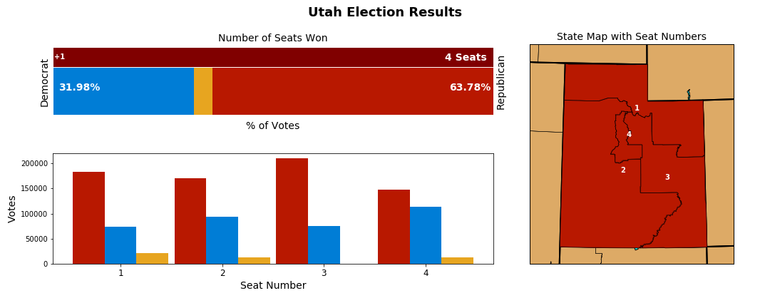

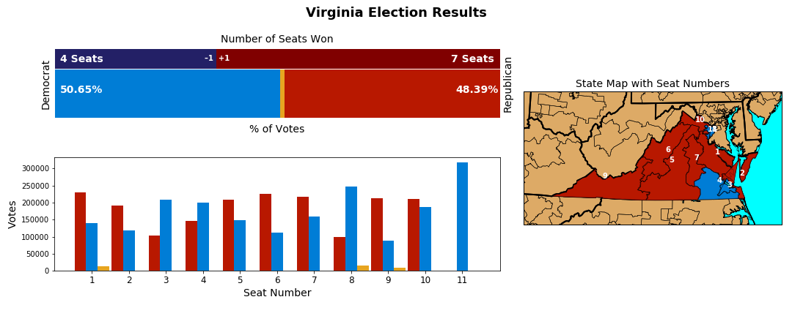

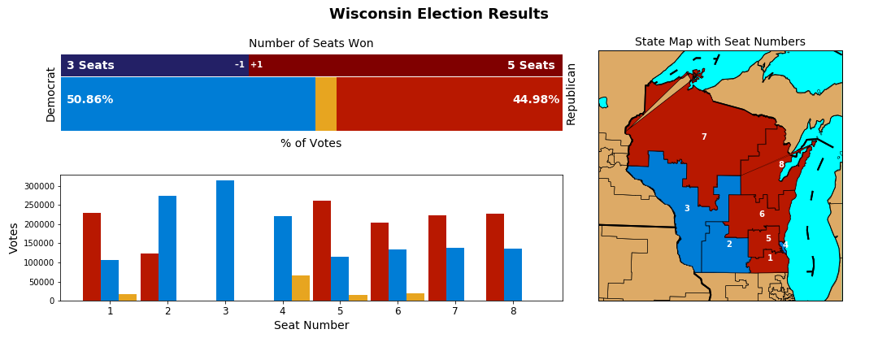

# Appendix B

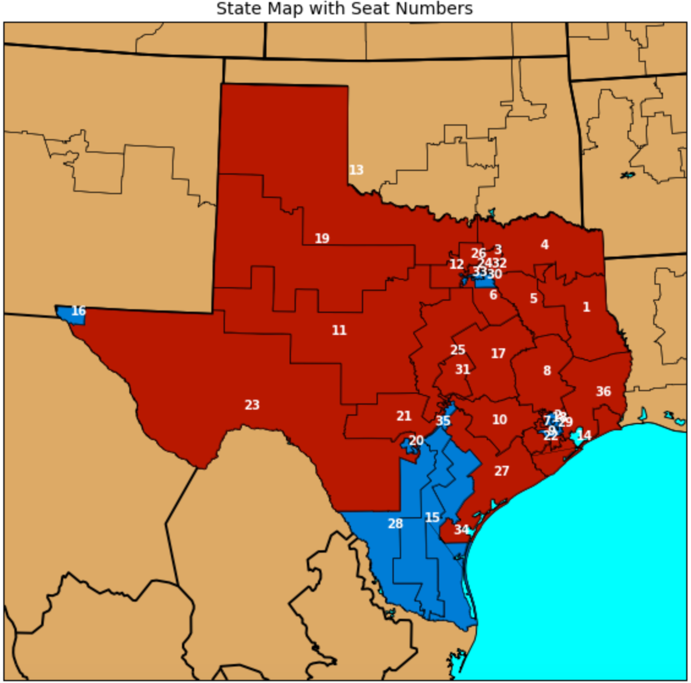

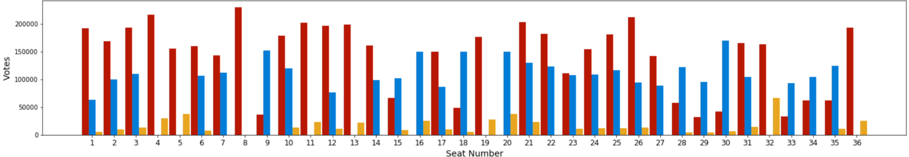

# Works Cited

Altman, Micah, et al. “Revealing Preferences: Why Gerrymanders Are Hard to Prove, and What to Do about It.” *By Micah Altman, Brian Amos, Michael P. McDonald, Daniel A. Smith :: SSRN*, 23 Mar. 2015, papers.ssrn.com/sol3/papers.cfm?abstract_id=2583528.

Bangia, Sachet, et al. *Quantifying Gerrymandering @ Duke*, Duke University, services.math.duke.edu/projects/gerrymandering/.

Cavell, Nic. “Gerrymandering Is Even More Infuriating When You Can Actually See It.” *Wired*, Conde Nast, 3 June 2017, www.wired.com/2016/01/gerrymandering-is-even-more-infuriating-when-you-can-actually-see-it.

“Cook Partisan Voting Index.” *Wikipedia*, Wikimedia Foundation, 15 Oct. 2017, en.wikipedia.org/wiki/Cook_Partisan_Voting_Index.

Current Partisan Gerrymandering Cases | Brennan Center for Justice, Brennan Center for Justice, 26 Apr. 2017, www.brennancenter.org/analysis/ongoing-partisan-gerrymandering-cases.

DeLancey, Billy. Lobbyists 4 Good, 4 Feb. 2017, www.lobbyists4good.org/single-post/2017/01/23/Is-this-the-root-cause-of-our-political-dysfunction.

Dews, Fred. “A Primer on Gerrymandering and Political Polarization.” *Brookings*, Brookings, 6 July 2017, www.brookings.edu/blog/brookings-now/2017/07/06/a-primer-on-gerrymandering-and-political-polarization/.

FairVote.org. “About Us.” FairVote, www.fairvote.org/about.

“Gerrymandering.” *FairVote*, FairVote.org, www.fairvote.org/gerrymandering#gerrymandering_key_facts.

“Gerrymandering.” *Wikipedia*, Wikimedia Foundation, 17 Oct. 2017, en.wikipedia.org/wiki/Gerrymandering.

Han, Patrick. “The Most Gerrymandered States Ranked by Efficiency Gap and Seat Advantage.” *Azavea - Beyond Dots on a Map*, Azavea, 19 July 2017, www.azavea.com/blog/2017/07/19/gerrymandered-states-ranked-efficiency-gap-seat-advantage/.

“House Election Results: G.O.P. Keeps Control.” *The New York Times*, The New York Times, 8 Nov. 2016, www.nytimes.com/elections/results/house.

“How Gerrymandered Is My State?” *Gerrymander.princeton.edu*, Princeton University, gerrymander.princeton.edu.

Ingraham, Christopher. “America’s Most Gerrymandered Congressional Districts.” *The Washington Post*, WP Company, 15 May 2014, www.washingtonpost.com/news/wonk/wp/2014/05/15/americas-most-gerrymandered-congressional-districts/?utm_term=.6acac63037ea.

———. “This Is the Best Explanation of Gerrymandering You Will Ever See.” *The Washington Post*, WP Company, 1 Mar. 2015, www.washingtonpost.com/news/wonk/wp/2015/03/01/this-is-the-best-explanation-of-gerrymandering-you-will-ever-see/?utm_term=.0c2983149766.

“Issue Brief: Gerrymandering.” *Reclaim the American Dream*, Reclaim, reclaimtheamericandream.org/brief-gerrymander/.

Kennedy, Merrit. *Supreme Court Agrees To Hear Wisconsin Gerrymandering Case*. NPR, 19 June 2017, www.npr.org/sections/thetwo-way/2017/06/19/533519165/supreme-court-agrees-to-hear-wisconsin-gerrymandering-case.

Koolbens. *Partisan Voting Index Calculator*. Daily Kos, 10 Dec. 2013, www.dailykos.com/stories/2013/12/10/1261624/-Partisan-Voting-Index-Calculator.

“List of United States Congressional Districts.” *Wikipedia*, Wikimedia Foundation, 3 Oct. 2017, en.wikipedia.org/wiki/List_of_United_States_congressional_districts#Alabama.

Mast, Tory. *FairVote - The History of Single-Member Districts for Congress*, Program for Representative Government, archive.fairvote.org/?page=526.

Petry, Eric. “How the Efficiency Gap Works.” www.brennancenter.org/sites/default/files/legal-work/How_the_Efficiency_Gap_Standard_Works.pdf.

“Power.” *Merriam-Webster*, Merriam-Webster, www.merriam-webster.com/dictionary/power.

“Redistricting.” *Common Cause*, www.commoncause.org/issues/voting-and-elections/redistricting/.

*The ReDistricting Game*, USC Game Innovation Lab, www.redistrictinggame.org/index.php.

*Reelection Rates Over the Years*. OpenSecrets.org, www.opensecrets.org/overview/reelect.php.

Roeder, Oliver. *The Supreme Court Is Allergic To Math*. FiveThirtyEight, 17 Oct. 2017, fivethirtyeight.com/features/the-supreme-court-is-allergic-to-math/.

Schwarzenegger, Arnold. “‘The Elections Are Rigged’ Arnold Schwarzenegger On Trump, Congress And More!” *YouTube*, YouTube, 29 Mar. 2017, www.youtube.com/watch?v=2w-pgvRsIuE.

———. “Terminate Gerrymandering.” *Crowdpac*, www.crowdpac.com/communities/arnold.

———. “Why Herpes Is More Popular Than Congress (Arnold Schwarzenegger).” *YouTube*, YouTube, 15 Feb. 2017, www.youtube.com/watch?v=Qfc3N0ZngXs.

“Silicon-Valley-Data-Science/Gerrymandering-Congress.” *GitHub*, Silicon Valley Data Science, github.com/silicon-valley-data-science/gerrymandering-congress.

Silver, Nate. “As Swing Districts Dwindle, Can a Divided House Stand?” The New York Times, The New York Times, 27 Dec. 2012, fivethirtyeight.blogs.nytimes.com/2012/12/27/as-swing-districts-dwindle-can-a-divided-house-stand/?_r=0.

“The State of Gerrymandering.” *Big Data Visualization: Congressional Gerrymandering*, Silicon Valley Data Science, svds.com/gerrymandering/.

Stephanopoulos, Nicholas. *Here's How We Can End Gerrymandering Once and for All*. New Republic, 2 July 2014, newrepublic.com/article/118534/gerrymandering-efficiency-gap-better-way-measure-gerrymandering.

Stephanopoulos, Nicholas O., and Eric M. McGhee. "Partisan gerrymandering and the efficiency gap." The University of Chicago Law Review (2015): 831-900.

*The Top 10 Most Gerrymandered States In America – Rantt*. Rantt, 25 May 2017, rantt.com/the-top-10-most-gerrymandered-states-in-america-bd962843ba1f.

“The Top 10 Most Gerrymandered States In America – Rantt.” *Rantt*, Rantt, 25 May 2017, rantt.com/the-top-10-most-gerrymandered-states-in-america-bd962843ba1f.

“United States Declaration of Independence.” *Wikipedia*, Wikimedia Foundation, 14 Oct. 2017, en.wikipedia.org/wiki/United_States_Declaration_of_Independence.

“United States House of Representatives Elections, 2016.” *Wikipedia*, Wikimedia Foundation, 15 Oct. 2017, en.wikipedia.org/wiki/United_States_House_of_Representatives_elections,_2016.

Wang, Sam. “Opinion | Let Math Save Our Democracy.” The New York Times, The New York Times, 5 Dec. 2015, www.nytimes.com/2015/12/06/opinion/sunday/let-math-save-our-democracy.html?_r=0.

Wang, Samuel S-H. "Three tests for practical evaluation of partisan gerrymandering." Stan. L. Rev. 68 (2016): 1263.

“Wasted Vote.” *Wikipedia*, Wikimedia Foundation, 13 Oct. 2017, en.wikipedia.org/wiki/Wasted_vote.

Wofford, Ben. “Does Gerrymandering Cause Polarization.” *End Gerrymandering Now*, North Carolina Common Cause, 15 July 2014, endgerrymanderingnow.org/2014/07/17/does-gerrymandering-cause-polarization/.

1. “Gerrymandering.” Wikipedia, Wikimedia Foundation, 17 Oct. 2017, en.wikipedia.org/wiki/Gerrymandering.
2. Current Partisan Gerrymandering Cases | Brennan Center for Justice, Brennan Center for Justice, 26 Apr. 2017, www.brennancenter.org/analysis/ongoing-partisan-gerrymandering-cases.
3. Ingraham, Christopher. “This Is the Best Explanation of Gerrymandering You Will Ever See.”The Washington Post, WP Company, 1 Mar. 2015, www.washingtonpost.com/news/wonk/wp/2015/03/01/this-is-the-best-explanation-of-gerrymandering-you-will-ever-see/?utm_term=.0c2983149766.
4. Mast, Tory. FairVote - The History of Single-Member Districts for Congress, Program for Representative Government, archive.fairvote.org/?page=526.
5. Stephanopoulos, Nicholas O., and Eric M. McGhee. "Partisan gerrymandering and the efficiency gap." The University of Chicago Law Review (2015): 831-900.
6. Stephanopoulos, Nicholas. Here's How We Can End Gerrymandering Once and for All. New Republic, 2 July 2014, newrepublic.com/article/118534/gerrymandering-efficiency-gap-better-way-measure-gerrymandering.
7. Kennedy, Merrit. Supreme Court Agrees To Hear Wisconsin Gerrymandering Case. NPR, 19 June 2017, www.npr.org/sections/thetwo-way/2017/06/19/533519165/supreme-court-agrees-to-hear-wisconsin-gerrymandering-case.
8. "Gill v. Whitford." Oyez, 18 Oct. 2017, www.oyez.org/cases/2017/16-1161.
9. “Wasted Vote.” Wikipedia, Wikimedia Foundation, 13 Oct. 2017, en.wikipedia.org/wiki/Wasted_vote.
10. “United States House of Representatives Elections, 2016.” Wikipedia, Wikimedia Foundation, 15 Oct. 2017, en.wikipedia.org/wiki/United_States_House_of_Representatives_elections,_2016.
11. FairVote.org. “About Us.” FairVote, www.fairvote.org/about.
12. Stephanopoulos, Nicholas O., and Eric M. McGhee. "Partisan gerrymandering and the efficiency gap." The University of Chicago Law Review (2015): 831-900. Page 865.
13. Altman, Micah, et al. “Revealing Preferences: Why Gerrymanders Are Hard to Prove, and What to Do about It.” By Micah Altman, Brian Amos, Michael P. McDonald, Daniel A. Smith :: SSRN, 23 Mar. 2015, papers.ssrn.com/sol3/papers.cfm?abstract_id=2583528.
14. Ingraham, Christopher. “This Is the Best Explanation of Gerrymandering You Will Ever See.”The Washington Post, WP Company, 1 Mar. 2015, www.washingtonpost.com/news/wonk/wp/2015/03/01/this-is-the-best-explanation-of-gerrymandering-you-will-ever-see/?utm_term=.0c2983149766.
15. DeLancey, Billy. Lobbyists 4 Good, 4 Feb. 2017, www.lobbyists4good.org/single-post/2017/01/23/Is-this-the-root-cause-of-our-political-dysfunction.
16. The Top 10 Most Gerrymandered States In America – Rantt. Rantt, 25 May 2017, rantt.com/the-top-10-most-gerrymandered-states-in-america-bd962843ba1f.
17. Cavell, Nic. “Gerrymandering Is Even More Infuriating When You Can Actually See It.” Wired, Conde Nast, 3 June 2017, www.wired.com/2016/01/gerrymandering-is-even-more-infuriating-when-you-can-actually-see-it.
18. The ReDistricting Game, USC Game Innovation Lab, www.redistrictinggame.org/index.php.
19. Schwarzenegger, Arnold. “Why Herpes Is More Popular Than Congress (Arnold Schwarzenegger).”, YouTube, 15 Feb. 2017, www.youtube.com/watch?v=Qfc3N0ZngXs.
20. Schwarzenegger, Arnold. “‘The Elections Are Rigged’ Arnold Schwarzenegger On Trump, Congress And More!”, YouTube, 29 Mar. 2017, www.youtube.com/watch?v=2w-pgvRsIuE.
21. Reelection Rates Over the Years. OpenSecrets.org, www.opensecrets.org/overview/reelect.php.
22. Dews, Fred. “A Primer on Gerrymandering and Political Polarization.” Brookings, Brookings, 6 July 2017, www.brookings.edu/blog/brookings-now/2017/07/06/a-primer-on-gerrymandering-and-political-polarization/.
23. McCarty, Nolan, Keith T. Poole, and Howard Rosenthal. "Does gerrymandering cause polarization?." American Journal of Political Science 53.3 (2009): 666-680.
24. McCarty, Nolan, Keith T. Poole, and Howard Rosenthal. "Does gerrymandering cause polarization?." American Journal of Political Science 53.3 (2009): 666-680.
25. Silver, Nate. “As Swing Districts Dwindle, Can a Divided House Stand?” The New York Times, The New York Times, 27 Dec. 2012, fivethirtyeight.blogs.nytimes.com/2012/12/27/as-swing-districts-dwindle-can-a-divided-house-stand/?_r=0.
26. “Cook Partisan Voting Index.” Wikipedia, Wikimedia Foundation, 15 Oct. 2017, en.wikipedia.org/wiki/Cook_Partisan_Voting_Index.
27. Koolbens. Partisan Voting Index Calculator. Daily Kos, 10 Dec. 2013, www.dailykos.com/stories/2013/12/10/1261624/-Partisan-Voting-Index-Calculator.
28. “The State of Gerrymandering.” Big Data Visualization: Congressional Gerrymandering, Silicon Valley Data Science, svds.com/gerrymandering/.
29. “Silicon-Valley-Data-Science/Gerrymandering-Congress.” GitHub, Silicon Valley Data Science, github.com/silicon-valley-data-science/gerrymandering-congress.
30. Han, Patrick. “The Most Gerrymandered States Ranked by Efficiency Gap and Seat Advantage.” Azavea - Beyond Dots on a Map, Azavea, 19 July 2017, www.azavea.com/blog/2017/07/19/gerrymandered-states-ranked-efficiency-gap-seat-advantage/.
31. Wang, Sam. “Opinion | Let Math Save Our Democracy.” The New York Times, The New York Times, 5 Dec. 2015, www.nytimes.com/2015/12/06/opinion/sunday/let-math-save-our-democracy.html?_r=0.
32. “How Gerrymandered Is My State?” Gerrymander.princeton.edu, Princeton University, gerrymander.princeton.edu.
33. Wang, Samuel S-H. "Three tests for practical evaluation of partisan gerrymandering." Stan. L. Rev. 68 (2016): 1263.
34. “Power.” Merriam-Webster, Merriam-Webster, www.merriam-webster.com/dictionary/power.
35. “United States Declaration of Independence.” Wikipedia, Wikimedia Foundation, 14 Oct. 2017, en.wikipedia.org/wiki/United_States_Declaration_of_Independence.
36. “Gerrymandering.” Wikipedia, Wikimedia Foundation, 17 Oct. 2017, en.wikipedia.org/wiki/Gerrymandering.
37. “House Election Results: G.O.P. Keeps Control.” The New York Times, The New York Times, 8 Nov. 2016, www.nytimes.com/elections/results/house.
38. Petry, Eric. “How the Efficiency Gap Works.” www.brennancenter.org/sites/default/files/legal-work/How_the_Efficiency_Gap_Standard_Works.pdf.
39. We grouped all votes for smaller parties into a single category “Other”. In our analysis there are therefore three parties: Republican, Democrat and Other.
40. Stephanopoulos, Nicholas O., and Eric M. McGhee. "Partisan gerrymandering and the efficiency gap." The University of Chicago Law Review (2015): 831-900. Page 831